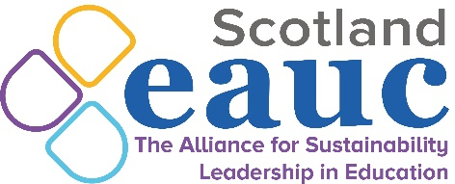

EAUC Scotland Winter Forum

24th January 2024 2-4pm

2.00 | Welcome and Introductions  Christine Calder, Dundee & Angus College and EAUC Scotland Convenor
2.10 | EAUC Scotland: Sustainability Champions Training Pack launch  Matt Woodthorpe, EAUC Scotland
2.25 | Green Gown Awards 2023: Enabling student impact at Glasgow Caledonian University (Winner in Benefitting Society category)  Jillian Watt and Frank Brown, Glasgow Caledonian University
2.40 | Green Gown Awards 2023: The SEEDABLE Curriculum (Winner in the Tomorrow’s Employees category)  Dr Pauline Hanesworth, Scotland’s Rural College (SRUC)
2.55 | Comfort Break
3.05 | Audit Scotland: Our approach to auditing climate change  Rebecca Seidel, Audit Scotland
3.35 | EAUC Scotland: Advisory Group applications and upcoming opportunities  Matt Woodthorpe, EAUC Scotland
3.50 | AOB  Christine Calder, Dundee & Angus College and EAUC Scotland Convenor
4.00 | Thanks and Close  Christine Calder, Dundee & Angus College and EAUC Scotland Convenor

