University of the West of Scotland wins national award for energy saving

The University of the West of Scotland triumphed, with a £500 prize, by coming first in the NUS “Snap it Off” campaign.

This was the first year that UWS took part in Snap it Off! and went straight to the top of the leader board, outperforming all other universities across the UK.

The idea of Snap it Off! was to ask students to take pictures of areas around the university where energy was being used unnecessarily; such as lights being left on throughout the day, and send them into the Snap it Off! website. The Sustainable Behaviours Coordinator at UWS was then alerted by NUS so that the energy wastage could be actioned.

The student that sent in the most photos of energy wastage was awarded with a Samsung Galaxy Tablet to help with their studies. The winner, final year Civil Engineering student, Chukwumela Okoroma, said “I am so glad to have won this prize and help put the University on top of the results table, especially considering it is such an important issue!”

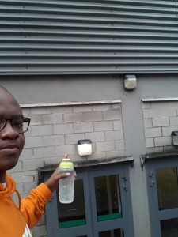
Jack Douglas, President of the Students’ Association commented: “This wouldn't have been possible without the dedication of our staff in the sustainability team and the many students that took up the opportunity to get involved in carbon saving activities. UWS students have a strong belief that we should be working towards a sustainable future and we are seeing an increasing amount of students that want to get involved and make a difference. At SAUWS, we look forward to build on this year's work as we start to prepare for the next academic year."

