Domestic and International Student Relocation Travel Emissions Calculator Tool – User Guide

Roederer rose lyne – University of Aberdeen net zero & emissions Manager
september 2023

Authors
Primary | Roederer Rose Lyne – University of Aberdeen Net Zero & Emissions Manager
Secondary | Matt Woodthorpe – EAUC Scotland Programme Manager

Version History
Version | Date | Authors | Reviewers | Notes
Draft 1 | 09/03/2023 | Estrid Jonsson – University of Aberdeen Net Zero Research – Travel Emissions Intern | Roederer Rose Lyne – University of Aberdeen Net Zero & Emissions Manager | Draft developed for the original tool
Version 1 | 27/09/2023 | Roederer Rose Lyne – University of Aberdeen Net Zero & Emissions Manager | Matt Woodthorpe – EAUC Scotland Programme Manager | Guidance for new tool

Contents
Abbreviations and Acronyms 5
Introduction 6
Note from the Developers 6
Rose Lyne – Net Zero & Emissions Manager – University of Aberdeen 6
Matt Woodthorpe – Scotland Programme Manager – EAUC 7
Flight Calculation Methodologies 8
Domestic Flights 8
Methodology A 8
Methodology B 8
International Flights 9
Methodology A 9
Methodology B 10
Methodology C 10
Methodology D 11
Recommendations 11
Using the Tool 13
Step 1: Request and Organise Domicile Data 14
Step 2: Enter Institution Information 14
Step 3: Enter Domicile Data 14
Step 4: Enter Country Capital Distances and Regions 15
Step 4.a UK Countries 15
Step 4.b International Countries 15
Step 5: Select Domestic Flight Calculation Methodology 16
Step 5.a: Domestic Flight Methodology A 16
Step 5.b: Domestic Flight Methodology B 16
Step 6: Select International Flight Calculation Methodology 18
Step 6.a: International Flight Methodology A 18
Step 6.b: International Flight Methodology B 18
Step 6.c: International Flight Methodology C 19
Step 6.d: International Flight Methodology D 20
Step 7: Customise Regional Locations 22
Step 8: Enter Emissions Factors 23
Step 9: Enter Travel Assumptions 24
Step 10: Update Country List 25
Tool Outputs 26
Appendix A – Student Survey Questions 27

List of Figures
Figure 1: Domestic Flight Calculation Methodology - A 8
Figure 2: Domestic Flight Calculation Methodology - B 9
Figure 3: International Flight Calculation Methodology - A 9
Figure 4: International Flight Calculation Methodology - B 10
Figure 5: International Flight Calculation Methodology - C 11
Figure 6: International Flight Calculation Methodology - D 11

Abbreviations and Acronyms

Abbreviation/Acronym | Description
GDPR | General Data Protection Regulation
GHG | Green House Gases
N America | North America
PBCCD | Scotland’s Public Bodies Climate Change Duties
S America | South America
SCEF | Standardised Carbon Emissions Reporting Framework
tCO₂e | Tonnes (t) of carbon dioxide (CO₂) equivalent (e)
UK | United Kingdom
WTT | Well-To-Tank

Introduction
This is a user guide to the “Domestic and International Student Relocation Travel Emissions Calculator Tool” develop by the University of Aberdeen and EAUC Scotland.
The tool uses student domicile data and university specific travel assumptions to calculate the distance travelled from the capital of each country to the institution and the associated emissions.
It should be noted that the tool is pre-populated with the assumption that international students would fly into London before travelling onto their institution through domestic flights or land-based travel modes. The tool does allow this to be changed if required but the user will need to manually add country level distance data.
The tool aligns with the Standardised Carbon Emissions Reporting Framework (SCEF) guidance for the Scope 3 “UK Student Travel & International Student Travel” category and Scotland’s Public Bodies Climate Change Duties (PBCCD) reporting requirements.
Please note, that this tool does not include Well-To-Tank (WTT) emissions from student travel. The outputs of the tool will allow these emissions to be calculated separately.
The tool does not require any identifiable student data (e.g., student IDs, names, etc.) to function. As such, there are no GDPR concerns.
For information on how the tool was developed, please refer to the research paper behind the finalised methodology, found in the following location:
www.sustainabilityexchange.ac.uk/public_bodies_climate_change_duties_reporting_t

Note from the Developers

Rose Lyne – Net Zero & Emissions Manager – University of Aberdeen
This tool is based upon the “Student Travel to Study Emissions Calculation Tool”, developed by Estrid Jonsson, a University of Aberdeen Net Zero Research – Travel Emissions Intern within the Estates & Facilities Sustainability Team, as her internship project.
The internship was established to fill a gap identified in the University’s emissions profile, as at the time, there was no formal methodology available within the sector to calculate these emissions.
In taking this remit forward, she researched the data and reporting standards required for the higher education sector’s emissions reporting, engaged with the sector to understand how other institutions were capturing and reporting these emissions, and finally developed a robust methodology and tool that enabled the University to calculate these emissions for the first time, enhancing our emissions reporting and contributing to our sustainability commitments articulated as part of our Aberdeen 2040 strategy.
Following engagement with the Higher Education Sector and EAUC Scotland, I have evolved the original tool to become the “Domestic and International Student Relocation Travel Emissions Calculator Tool”. Providing increased granularity, flexibility, and customisation as to align with reporting requirements, best practice, and to allow use by any institution.
At the University of Aberdeen, we include the calculated emissions data in our annual PBCCD submission and in our public Sustainability Dashboard.

Matt Woodthorpe – Scotland Programme Manager – EAUC
EAUC are pleased to publish this tool for the UK Further and Higher Education sector in partnership with the University of Aberdeen. Domestic and international student relocation travel emissions form a significant proportion of institutional emissions: for example, within 2020/21 PBCCD reporting, these emissions accounted for 22% of total reported emissions for one of the few institutions currently reporting their student relocation emissions.
Yet, domestic and international student relocation travel emissions are often not reported by the sector; this is largely due to the internal capacity needed to create an internal methodology for calculation. The tool presented here helps address this critical capacity challenge. The tool also helps institutions fulfil the principles of emissions reporting under the Greenhouse Gas (GHG) Protocol, aligns with the sector’s Standardised Carbon Emissions Framework, and, for Scottish institutions, will help the sector meet the expectations set out in the latest public sector bodies guidance from Scottish Government.
EAUC hopes that the creation of a user-friendly tool will enable the reporting of student relocation emissions to become the norm across the sector. We encourage all institutions to calculate and report on these emissions, noting that they highlight one of the principal areas in which student recruitment, internationalisation, and sustainability strategies intersect.

Flight Calculation Methodologies
A selection of calculation methodologies is available for domestic and international flights, enabling users to develop travel assumptions that reflect the transport infrastructure around their institution.

Domestic Flights
The calculation methodology for domestic flights taken by UK/Home students has been expanded to enable customisation of the land-based travel method from the nearest airport to the institution:
- Domestic Methodology A - Unknown Final Land Travel Method
- Domestic Methodology B - Known Final Land Travel Method

Methodology A
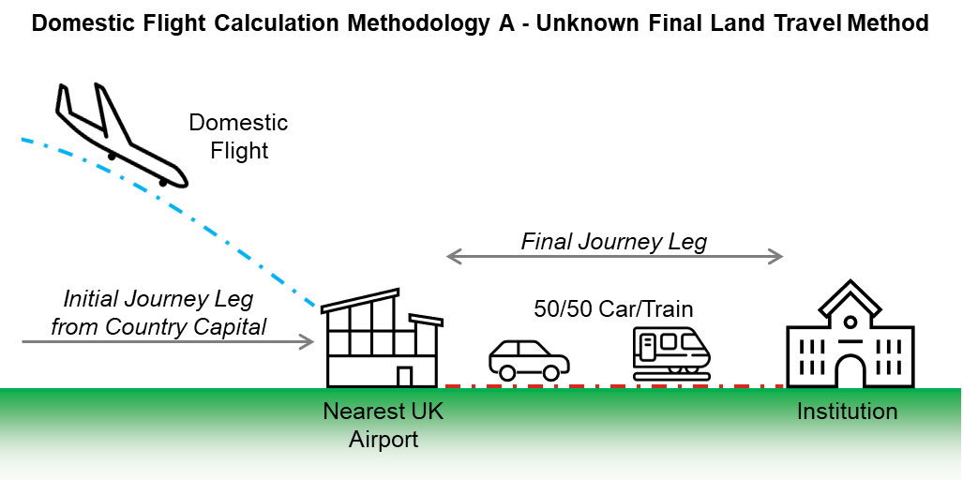
This methodology assumes that a UK/Home student will fly from their domicile capital to the nearest airport to the institution and the final leg of the journey is undertaken via an unknown land-based method. As the travel method for the final leg is unknown, it is assumed to be a 50/50 split between car and rail.
Figure 1: Domestic Flight Calculation Methodology - A

Methodology B
If an institution knows the travel methods its student’s take for the final leg of the journey, or if the 50/50 split between car and rail used in Methodology A is not reflective of the travel infrastructure to the institution, then Methodology B can be used.
As with Methodology A, it is assumed that a student will fly to the nearest airport from the country capital and then travel the final leg to the institution via a land-based method. Methodology B allows for the user to enter a percentage split between the following land-based travel methods:
- Car
- Rail
- Coach
- Local Bus
- taxi
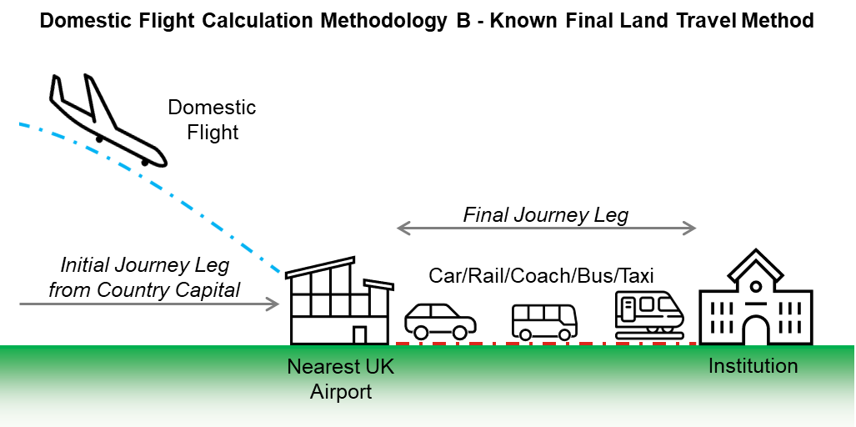
Figure 2: Domestic Flight Calculation Methodology - B

International Flights
To fully reflect the variety of ways international students reach their institutions, four calculation methodologies have been developed for international flights to account for travel from landing location to an institution:
- International Methodology A - One Airport Location and Unknown Final Land Travel Method
- International Methodology B - One Airport Location and Known Final Land Travel Method
- International Methodology C - Layover and Regional Airports and Unknown Final Travel Method
- International Methodology D - Layover and Regional Airports and Known Final Travel Method

Methodology A
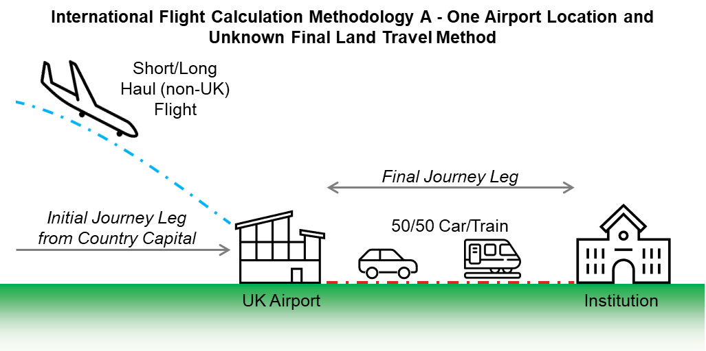
It is assumed that a student will fly into an UK airport from the country capital and then travel the final leg to the institution via an unknown land-based method. As the travel method for the final leg is unknown, it is assumed to be a 50/50 split between car and rail.
Figure 3: International Flight Calculation Methodology - A

Methodology B
If an institution knows the travel methods its student’s take for the final leg of the journey, or if the 50/50 split between car and rail used in Methodology A is not reflective of the travel infrastructure to the institution, then Methodology B can be used.
As with Methodology A, it is assumed that a student will fly into an UK airport from the country capital and then travel the final leg to the institution via a land-based method. Methodology B allows for the user to enter a percentage split between the following land-based travel methods:
- Car
- Rail
- Coach
- Local Bus
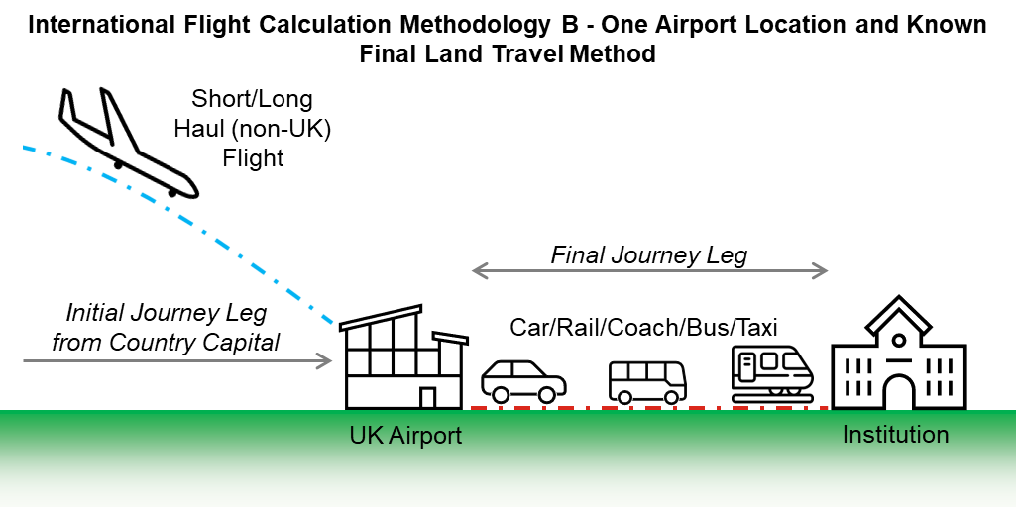
- Taxi
Figure 4: International Flight Calculation Methodology - B

Methodology C
If an institution reviews the air travel options for its students and finds that the majority of international flights are directed through a central layover airport (e.g., London Heathrow) before flying to a more local regional airport, then Methodologies A and B will not be suitable.
Methodology C is similar to Methodology A, where the land-based travel method for the final leg of a student’s journey from the airport is unknown, however, it also incorporates the inclusion of a middle leg of the journey from a central airport to a regional one. As the travel method for the final leg is unknown, it is assumed to be a 50/50 split between car and rail.
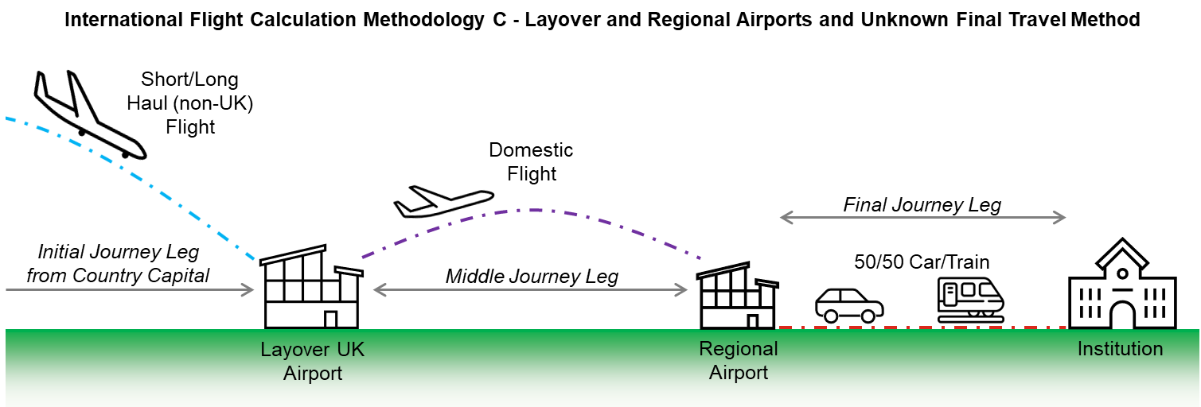
The tool calculates the flight emissions resulting from the middle leg of the journey using the UK “domestic flights” emission factor.
Figure 5: International Flight Calculation Methodology - C

Methodology D
If an institution expects students to travel via regional airport and knows the travel methods its student’s take for the final leg of the journey, or if the 50/50 split between car and rail used in Methodology C is not reflective of the travel infrastructure to the institution, then Methodology D can be used.
As with Methodology C, it is assumed that a student will fly into a regional airport and then travel the final leg to the institution via a land-based method. Methodology D allows for the user to enter a percentage split between the following land-based travel methods:
- Car
- Rail
- Coach
- Bus
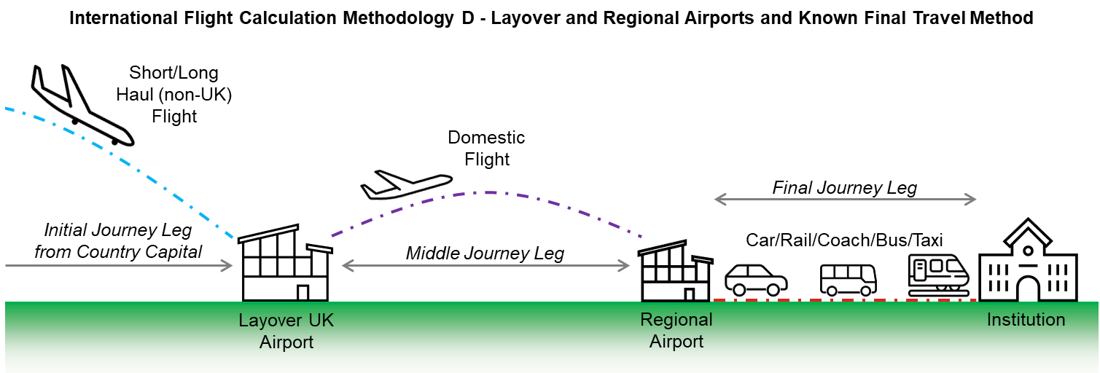
- Taxi
Figure 6: International Flight Calculation Methodology - D

Recommendations
There are a number of recommendations for institutions when using the tool:
- Assume only 1 return journey (i.e., 2 trips a year) unless an institution’s residential halls close over holiday periods (e.g., Christmas).
- Institutions should undertake regular (i.e., once every year or two) surveys of their student populations to ensure travel assumptions are reflective. Appendix A includes a copy of the questions included in the University of Aberdeen’s survey.

Using the Tool
The tool collates the entered student domicile data, travel assumptions, and distance data to calculate emissions data for each country.
The workbook contains the following 9 worksheets:
Worksheet | Description
Cover Page | A worksheet which provides a brief overview of the tool and guides for sources of data, and shows the following:  - Person who completed the workbook  - Reporting year  - Institution name  - Home Country
Country and Student Data | A worksheet showing the following:  - Distance to institution from country capital for UK countries  - Distance to layover location from international country capitals  - Total number of students from each country  - Region classification for each country
Flight Methodologies | A worksheet showing the following:  - International Flight Methodology  - Domestic Flight Methodology  - Regional airports  - Distance from layover location to regional airports
Emission Factors | A worksheet showing the following:  - Reporting year emission factors  - Historic emission factors
Calculation of Emissions | A worksheet showing the following:  - Number of trips for each country  - Travel assumptions for each country  - Total emissions for each travel method for each country
Summary and Analysis | A worksheet showing the following:  - Overall summaries  - Travel summaries  - Region summaries

Only complete areas which are highlighted green.

Step 1: Request and Organise Domicile Data
Request annual domicile student data from the relevant department in the institution for campus and blended registered students. Organise the data in a separate workbook so that you have a list of each country and the total number of students for each.

Step 2: Enter Institution Information
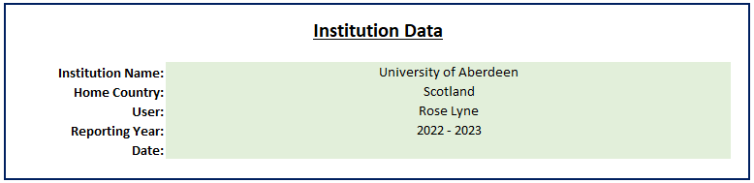
Complete the following sections in the “Cover Page” worksheet:

Step 3: Enter Domicile Data
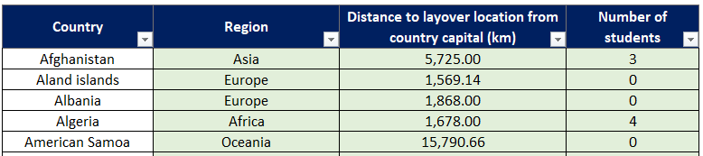
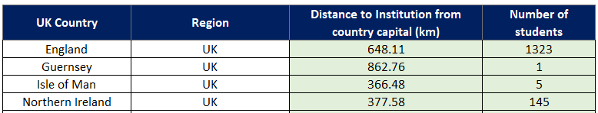
In the “Country and Student Data” worksheet, enter the associated student totals compiled in Step 1 against each of the countries listed.
Any new countries can be inserted at the bottom of the international table along with their region, distance, and student number data.

Step 4: Enter Country Capital Distances and Regions

Step 4.a UK Countries
Enter the distance from the UK country capitals to the institution in the “Country and Student Data” worksheet using the following website: https://www.distance.to.

Step 4.b International Countries
The tool is pre-populated assuming the default layover location is London, with the distances from each international country capital to London entered in the “Country and Student Data” worksheet. This data is from the following dataset: http://ksgleditsch.com/data-5.html.
If a different layover location than London is being used, then the distance from each international country capital to the selected location can be found from the following website: https://www.distance.to.
Enter the new distances in the “Country and Student Data” worksheet.
A region for each country has also been pre-populated but this can be changed by selecting select a region classification from the drop-down list.
Any new countries can be inserted at the bottom of the international table along with their region, distance, and student number data.

Step 5: Select Domestic Flight Calculation Methodology
The flight calculation methodologies for domestic flights should now be selected in the “Flight Methodologies” worksheet and the relevant data inserted.

Step 5.a: Domestic Flight Methodology A
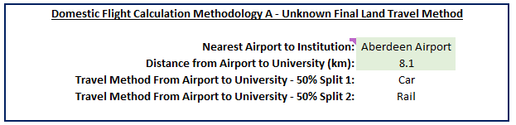
Select airport location from the drop-down list.
Enter the driving distance in kilometres from the landing location to the institution which can be sourced from Google Maps.

Step 5.b: Domestic Flight Methodology B
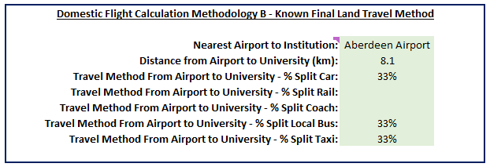
Select airport location from the drop-down list.
Enter the driving distance in kilometres from the landing location to the institution which can be sourced from the following website: https://www.distance.to/

Enter a percentage split value for each travel method.

Step 6: Select International Flight Calculation Methodology
The flight calculation methodologies for international flights should now be selected in the “Flight Methodologies” worksheet and the relevant data inserted.

Step 6.a: International Flight Methodology A
As highlighted in Step 4.b, the tool is pre-populated with London being the default layover location.
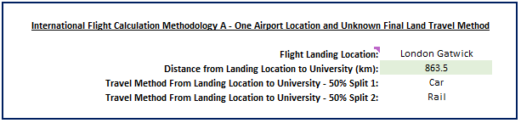
If a different layover location is being used, then select airport location from the drop-down list.
Enter the driving distance in kilometres from the landing location to the institution which can be sourced from the following website: https://www.distance.to/

Step 6.b: International Flight Methodology B
As highlighted in Step 4.b, the tool is pre-populated with London being the default layover location.
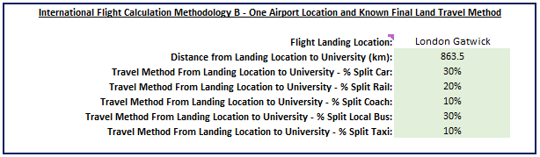
If a different layover location is being used, then select airport location from the drop-down list.
Enter the driving distance in kilometres from the landing location to the institution which can be sourced from the following website: https://www.distance.to/ .

Enter a percentage split value for each travel method.

Step 6.c: International Flight Methodology C
As highlighted in Step 4.b, the tool is pre-populated with London being the default layover location.
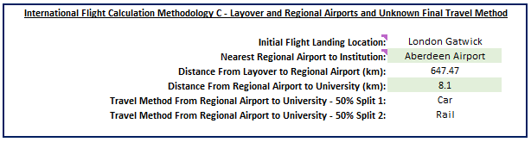
If a different layover location is being used, then select layover airport location from the drop-down list.
Select regional airport location from the drop-down list.
Enter the driving distance in kilometres from the regional airport to the institution which can be sourced from Google Maps.

Step 6.d: International Flight Methodology D
As highlighted in Step 4.b, the tool is pre-populated with London being the default layover location.
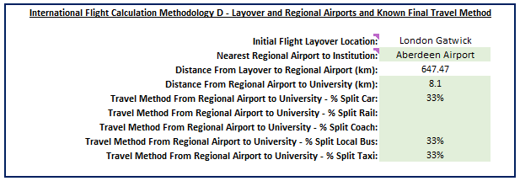
If a different layover location is being used, then select a layover airport location from the drop-down list.
Select regional airport location from the drop-down list.
Enter the driving distance in kilometres from the regional airport to the institution which can be sourced from Google Maps.

Enter a percentage split value for each travel method.

Step 7: Customise Regional Locations
As highlighted in Step 4.b, the tool is pre-populated with London being the default layover location.
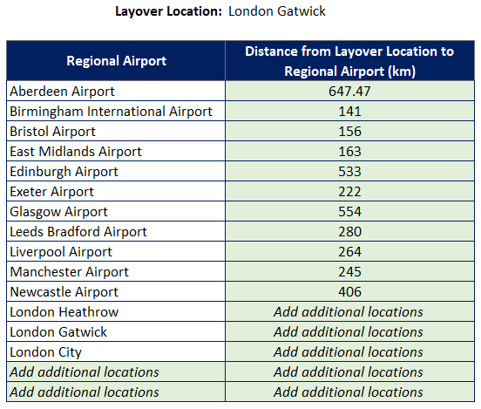
If a different layover location is being used, update the distance data between flight layover location and regional airports in the “Flight Methodologies” worksheet using the following website: https://www.distance.to

Step 8: Enter Emissions Factors
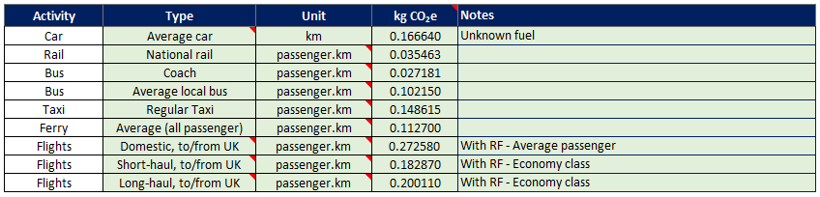
For each travel method, source and enter the relevant emission factors from the annual UK Government developed dataset into the “Emission Factors” worksheet: https://www.gov.uk/government/collections/government-conversion-factors-for-company-reporting
Please note that if, for example, calculations for the academic year 2015/2016 are made, emission factors for 2016 should be used, as a majority of the academic year falls within this year.
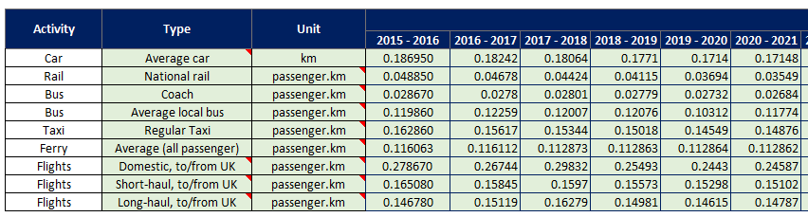
Historic data can also be entered in this worksheet.

Step 9: Enter Travel Assumptions
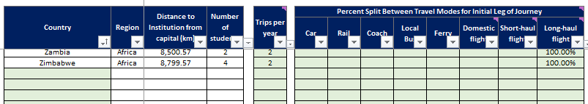
The list of default countries in “Country and Student Data” is already pre-populated but any new countries can be inserted at the bottom of the table in the “Calculation of Emissions” worksheet. The “Country” column can be sorted alphabetically once all countries have been entered.
Enter the assumed number of trips per year taken by each student. For 1 return trip (i.e., journey to an institution at the start of term and the return journey home at the end of term) enter the value “2”.
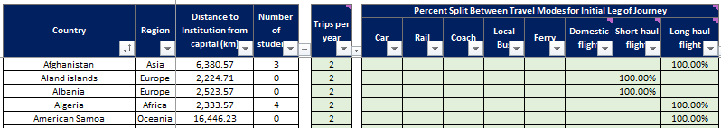
It is recommended that a user assumes only 1 return journey (i.e., 2 trips a year) unless their institution’s residential halls close over holiday periods (e.g., Christmas).
For each country, enter the initial journey leg travel mode assumption splits (i.e., when entering % assumptions for flights, do not also add % assumptions for car/rail/etc. for the final leg of the journey to the institution). The tool will automatically calculate the emissions from any middle and end journey legs as detailed in the "Flights Methodology" worksheet.
For simplicity the same travel mode can be assumed for each country in a region. Regular travel surveys can allow these assumptions to become more granular.

Step 10: Update Country List
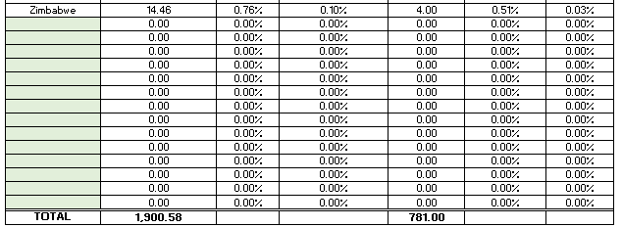
If any new countries have been added to the tool in previous worksheets, add it to the relevant region table in the “Summary and Analysis” worksheet.

Tool Outputs
The “Summary and Analysis” worksheet collates the total emissions and distances travelled for each travel mode and provides a variety of summaries, analysis and graphs:
- Total emissions and students by region and their associated proportion of the institution’s total student relocation emissions.
- Total emissions and distance travelled for each travel mode and for each region, and their associated proportion.
- Region breakdown showing total emissions for each country and proportional analysis.
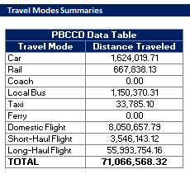
For the completion of an institution’s annual PBCCD submission, the “PBCCD Data Table” provides the total distance data for each travel mode. When completing the submission, ensure a note is entered explaining that the relocation tool was used to calculate the data, and any other relevant information.

Appendix A – Student Survey Questions

The following questions were included in the University of Aberdeen’s 2023 Staff & Student Transport Survey to inform our student relocation travel mode assumptions.

Home Address Travel

The University would like to learn more about the emissions associated with student travel between your permanent home address and the University. This includes any rail, air or other travel to Aberdeen at the beginning and end of the academic year. This section is not about your daily commuting travel while you are in Aberdeen; there will be separate questions about your daily commuting habits later in the survey. In the following questions we are interested only in travel between your permanent home address and Aberdeen e.g., coming to Aberdeen at the start of the academic year, and going home during term to visit family.

 | Which of the following best represents your permanent home address?
 | q | Scotland - Local (within a daily commutable distance of Aberdeen) e.g., Aberdeenshire |  | q | Asia and the Middle East
 | q | Scotland - Other (in Scotland but not within an easy commutable distance of Aberdeen) e.g., Glasgow |  | q | North America, Central America, and the Caribbean
 | q | UK - Outside Scotland |  | q | South America
 | q | Europe |  | q | Australia and Oceania
 | q | Africa |  | q | Other
 | Other (Please Specify)
 | _______________________________________________________________________________________________________________________________________________

How often do you make a return trip between your permanent home address and the University? Please count the journey to Aberdeen at the start of the academic year and home at the end of the academic year as one return trip.
q | 1 return journey - (at the start and end of the academic year only)
q | 2 return journeys (at the start and end of the academic year plus an additional return trip, for example over the winter holiday period)
q | 3 return journeys
q | 4 or more return journeys

 | What is your MAIN mode of transport between your home address and the University?
 | q | Car |  | q | Aeroplane (Economy)
 | q | Bus |  | q | Aeroplane (Business or First Class)
 | q | Train |  | q | Other
 | Other (Please Specify)
 | _______________________________________________________________________________________________________________________________________________

