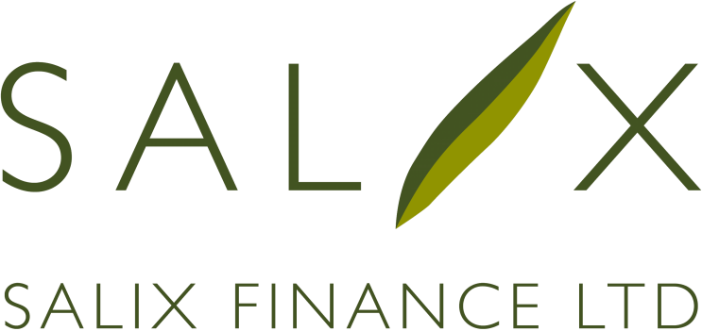

COMPLETION CERTIFICATE

Public Sector Body …………………………………………………………………
Name of Authorised Officer …………………………………………………………………
Position of Authorised Officer …………………………………………………………………

Project ID | Project details | Project cost(s) applied for | Final project cost(s) | Completion date(s)
 | Total loan value requested |  | £

Project Amendments
If there have been any changes to the scope, cost or any other information previously given on compliance tools relating to the above projects, detail the changes in the attached addendum and return with a new compliance tool for the changed projects.
Are there any amendments to the above projects?
- Yes
- No
This document certifies the completion of the above referenced project(s) (the “Project(s)”) undertaken by the public sector body named above (the “Public Sector Body”) in line with the requirements of Salix Finance Ltd. The Public Sector Body acknowledges that on the signing of this certificate a loan agreement (the “Loan Agreement”) will be entered into between the Public Sector Body and Salix Finance Ltd to document the funding that the Public Sector Body is to receive for the Project.
The Public Sector Body acknowledges, understands and agrees that any funding received from Salix Finance Ltd is based on the Public Sector Body having completed the Project(s) within the timescale, costing and remit for the Project as agreed with Salix Finance Ltd and that this Completion Certificate should only be executed when the Public Sector Body is satisfied that the Project(s) has been completed to and in compliance with this required standard.
The Public Sector Body further acknowledges, understands and accepts that Salix Finance Ltd will rely on this Completion Certificate and the certifications and confirmations contained within it when entering into the Loan Agreement and when making any loan to the Public Sector Body. As such, the Public Sector Body acknowledges, understands and agrees that if any confirmation or certification stated in this Completion Certificate proves to be untrue or incapable of being substantiated, that any loan made by Salix Finance Ltd to the Public Sector Body may become immediately repayable in full.
Declaration
I, the above named Authorised Officer, confirm that I am duly authorised by the Public Sector Body to make, and do make, the following confirmations and certifications on behalf of the Public Sector Body.
I confirm that the Project(s) has been completed within the agreed timescale and that the final costs of the Project(s) remain compliant with the terms of our application or as otherwise agreed with Salix Finance Ltd. I further confirm that the Project(s) is, and will at all times during the term of the proposed loan remain compliant with all the conditions and requirements of the Salix Finance Ltd Energy Efficient Loan Scheme.
I also confirm that the Public Sector Body has maintained, and will continue to maintain, clear records of the Project(s), including detailed costings, such that the Project(s) and the records may be audited by Salix Finance Ltd (or an agent or contractor on their behalf) or any governmental body if required.
I confirm that a detailed and diligent assessment of the Project(s) has been undertaken with all due care and skill such that the energy savings and CO2 reductions that the Project(s) was to produce, as agreed with Salix Finance Ltd, can be fully substantiated.

Signed …………………………………………………………………
Name (please print) …………………………………………………………………
Dated …………………………………………………………………
For and on behalf of …………………………………………………………………
Addendum
Project Amendments
Project ID | Summary of Change

