Global Universities Partnership on Environmental and Sustainability (GUPES)
Innovations in Higher Education and Sustainability
Launch of Platform for Sustainable Performance in Education
Green Room Event, 16.00–18.00hrs
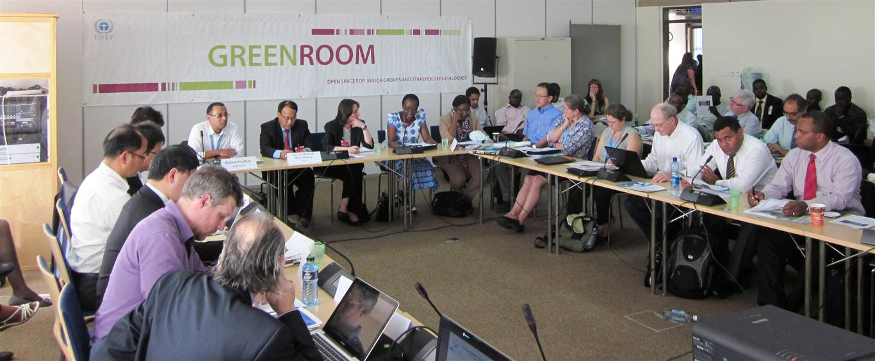20 February 2013 – UNEP HQs, Gigiri

- Ms Elizabeth Mrema, Deputy Director of UNEP’s Division of Environmental Policy Implementation, welcomed participants and highlighted UNEP’s enhanced engagement with Universities through the GUPES platform, with focus on education, training and networking;
- H.E. Ms Khatuna Gogaladze, Minister of Environmental Protection, Georgia stressed the importance of environmental education, as a follow-up to Rio+20 Outcome document – The Future We Want, as well as the Tbilisi+35 Communiqué – Educating Today for a Sustainable Future;
- H.E. Dr Keshab Man Shakya, Minister of Science, Technology and Environment, Nepal highlighted the need for capacity development in the context for developing countries, and the need to close the gap between supply and demand vis-à-vis education and employment opportunities;
- Peggy Oti-Boateng, Senior Program Specialist, Science and Technology, UNESCO highlighted the UN Decade of Education for Sustainable Development, and the African Network of Science and Technology Institutions;

- Platform for Sustainable Performance in Education: JC Carteron and Iain Patton provided a briefing and demonstration, which included an array of sustainability assessment tools to support Universities in adopting strategic approaches to implement and monitor their sustainability commitments – One Platform, Multiple Tools. Universities were encouraged to submit additional tools and case studies from both developed and developing regions, as a “living” Platform. This was a specific follow-up (Outcome to Implementation) of the Higher Education Sustainability Initiative (HESI), which was launched by an umbrella group of UN agencies during Rio+20, and featured sustainability commitments from over 270 University Presidents from across the globe.

- Panel Discussion: Representatives from 9 Universities in Africa, Asia, Europe, Latin America and North America highlighted innovations in higher education for sustainability, such as:
- Curriculum innovations: Transformative learning, transdisciplinary and policy relevant courses, and development of leadership programmes on sustainability, and scholarships;
- Campus operations: Green campus concepts and approaches, sustainability oriented universities, systems based approaches and low carbon campus concepts, including energy efficiency, water use and waste reduction and recycling programmes on campus;
- Community/policy engagement: Universities working with communities to value ecosystems, South-South and North-South partnerships and case studies, active University networks at regional levels; and ensuring service and solutions based, with strong policy linkages.

The Green Room event was attended by nearly 70 participants, and served as a pre-cursor to 7th World Environmental Education Congress, which will be held during 9-14 June 2013 in Morocco.

