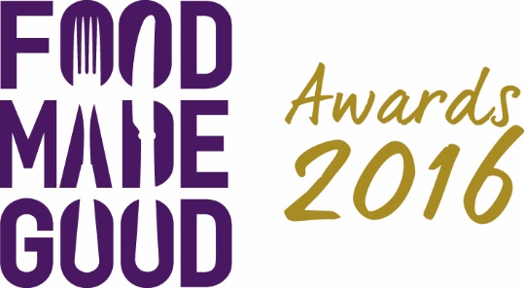

Food Made Good Awards 2016
The winners
22 March 2016

Food Made Good Independent Restaurant of the Year
Sponsored by Shaftesbury

WINNER:
Poco, Broadway Market, London

RUNNERS-UP:
cafe-ODE, Ness Cove, Devon
Captain’s Galley, Scrabster

Food Made Good Small Group of the Year
Supported by StreetSmart
WINNER:
Daylesford, Gloucestershire and London

RUNNERS-UP:
Hawksmoor, London and Manchester
Lussmanns Fish & Grill, Hertfordshire

Food Made Good Large Group of the Year
Sponsored by Chapman Ventilation

WINNER:
Wahaca
RUNNERS-UP:
Boston Tea Party
Carluccio’s
Geronimo Inns

Food Made Good Award for Environment
Sponsored by SWR

WINNER:
Arbor at The Green House Hotel, Bournemouth

RUNNERS-UP:
The Bay Fish & Chips, Aberdeenshire
Poco, Bristol

Food Made Good Award for Society
Sponsored by Nestlé Professional

WINNER:
Artizian Catering Services

RUNNERS-UP:
The Brookwood Partnership
Gather & Gather
THE PIG Hotel, Brockenhurst, Hampshire

Food Made Good Award for Sourcing
Sponsored by Reynolds

WINNER:
River Cottage HQ, Devon

RUNNERS-UP:
cafe ODE at Ness Cove and Gara Rock, both Devon
Poco, Bristol

Sustainable Innovation Award
Sponsored by Belu

WINNER:
bio-bean

RUNNERS-UP:
Foodspeed
Virgin Atlantic Airways

The following four award categories are all sponsored by Eureka Executive and the highest rated overall was named Food Made Good Restaurant of the Year 2016.
English Food Made Good Champion 2016
WINNER:
Poco, Broadway Market, London

RUNNERS-UP:
cafe-ODE Ness Cove, Devon
Daylesford, Gloucestershire and London

Scottish Food Made Good Champion 2016
WINNER:
The Captain’s Galley, Scrabster

RUNNERS-UP:
The Bay Fish & Chips, Aberdeenshire
Cafe St Honoré, Edinburgh

Welsh Food Made Good Champion 2016
WINNER:
The Gallery, Barry

RUNNER-UP:
The Clink Restaurant at HMP Cardiff

Irish Food Made Good Champion 2016
WINNER:
KSG at University College Cork

RUNNERS-UP:
Ashford Castle, County Mayo
The Lodge at Ashford Castle, County Mayo

Food Made Good Restaurant of the Year 2016

WINNER:
Poco, Broadway Market

Food Made Good Caterer of the Year
Sponsored by U-Select by PKL

WINNER:
bartlett mitchell

RUNNERS-UP:
Artizian Catering Services
The Brookwood Partnership

Best Food Waste Strategy
Sponsored by Unilever Food Solutions

WINNER:
FoodInResidence, The University of Manchester

RUNNERS-UP:
Pizza Express
Vacherin

Most Improved Sustainability
Sponsored by Paper Round

WINNER:
The Roebuck, London
RUNNERS-UP:
The Brookwood Partnership
Gather & Gather

International Food Made Good Champion 2016
WINNER:
Relæ, Denmark

RUNNERS-UP:
Les Orangeries, France
The Lodge Verbier, Switzerland

The People’s Favourite
Sponsored by Independent on Sunday

WINNER:
Lussmanns Fish & Grill, St Albans

RUNNERS-UP:
The Cafe in the Park, Rickmansworth
The Gallivant, Camber
Gillam’s Tearoom, Ulverston
Yeo Valley HQ Canteen, Blagdon

The Raymond Blanc Sustainability Hero Award
WINNER:
Jamie Oliver
Food Made Good University Champion
Sponsored by TUCO

WINNER:
Plymouth University

RUNNERS-UP:
University College Cork (KSG)
Durham University

Food Made Good Supplier of the Year
Supported by Hospitality Action
WINNER:
Delphis Eco

RUNNERS-UP:
London Linen Group
Trenchmore Farm

