Environmental Champion Engagement Case Study
As a group, develop a plan to engage with a team of environmental champions across your small campus.
Features of the campus and occupants:
- Mixture of 5 office buildings, a facilities management and office and yard, 10 mixed use teaching and learning buildings and a Students’ Union
- Each building has a sub meter
- All office staff working regularly between 9 – 5, taking lunch variously between 1200 – 1400
- Buildings not in use at the weekends
- Access to email staff, use noticeboards and entry in newsletter

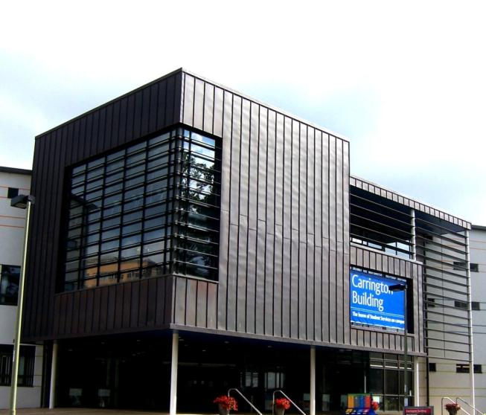
Points to consider:
- How much data do you want to give your ECs?
- How will you present the data?
- What are the possible actions?
- How will they have the opportunity to act?
- How many champions do you expect to have?
- Frequency of your actions, e.g. coordination.

