Education for
Sustainable Development Toolkit

Alex Meredith
Nottingham Trent University

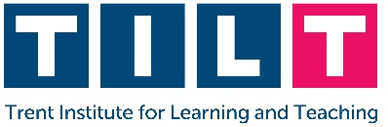

Key Points

Sustainability is best thought of as a multi-dimensional construct

It is commonly broken down into Environmental, Social, and Economic factors

Education for Sustainable Development is best served by emphasising the inter- and intra-disciplinary aspects of sustainable behaviours

Experiential learning is a powerful tool in helping students to engage with a topic, and to feel that they have the capacity to make positive changes

Table of Contents

Key Points 1
Table of Contents 2
General Introduction 3
Brief Review of the Literature 4
United Nations Sustainable Development Goals (UN SDGs) 7
Teaching Activities 11
Beginner Activities 12
Intermediate Activities 16
Advanced Activities 20
Examples of Good Practice 23
NTU - Nottingham Business School 23
NTU – School of Science & Technology 24
Links to Additional Resources 26
References 27

General Introduction

Welcome to the Nottingham Trent University (NTU) Education for Sustainable Development Toolkit. This toolkit is designed to help you in teaching about sustainability and to provide you with links to additional resources, both internal and external to NTU. Whilst the toolkit cannot provide you with specific content for a session (given individual session aims, module learning outcomes, and the breadth of courses at the University), it is hoped that it may provide some inspiration for the provision of Education for Sustainable Development (ESD).
The ESD Toolkit is also aligned with the wider University strategic aims as part of ‘University, reimagined’ – most obviously in Embracing Sustainability. However, ESD encourages us to look at the ‘big picture’, and crucially to develop multi-dimensional understandings of environmental, social, and economic issues. As such, it can also encourage students to Connect Globally in seeing themselves as global citizens. Finally, ESD can inspire students to see themselves as agents of positive change by developing nuanced understandings and novel solutions to contemporary issues – as such, it has a role in Empowering people.
There are six main sections to the toolkit:
- Brief review of the literature
- United Nations Sustainable Development Goals (UN SDGs)
- Teaching Activities
  - Beginner
  - Intermediate
  - Advanced
- Assessment Strategies
- Examples of Good Practice
- Links to Additional Resources
Finally, this toolkit is a work in progress and there is the intention to produce an online, interactive version. If you have any feedback / suggestions and wish to contribute to further iterations, please contact the author Alex Meredith (alexander.meredith@ntu.ac.uk).

Brief Review of the Literature

In 2015, all United Nations member states adopted the 17 Sustainable Development Goals (SDGs) as a template for action – setting out a model of the world that emphasised social, economic, and environmental progress, with no country or community left behind. As part of the ‘2030 Agenda for Sustainable Development’ the goals are integrated and recognise that world development must tackle basic inequalities such as poverty and other deficiencies whilst also considering issues such as gender inequality and climate change. It is a bold target and not without its challenges, but Universities can play a critical role in educating and empowering future leaders of society and business to address these goals (Barber et al., 2014; Barth et al., 2016; Boca & Saraçli, 2019; Kalinowska & Batorczak, 2015).
Typically students have better knowledge in those areas of sustainable behaviour that more naturally relate to their course (Fisher & McAdams, 2015); for example, Mesquita and Missimer (2020) found that engineering students were more cognizant of issues relating to sustainable consumption and industry, but had less understanding of social issues. Similarly, in one study economics students were found to have poor environmental knowledge with respect to their given topic (Kalinowska et al., 2016). Notwithstanding this, students tend to have better awareness of environmental issues, potentially because they can more easily see the impact of climate change and single use plastic, etc. (García-González et al., 2020).
However, multiple studies have shown that students do respond positively to teaching on sustainable behaviours (Pauw et al., 2015; Pujol & Tomás, 2020; Yoon et al., 2016; Zelenika et al., 2018). Some issues need to be addressed in terms of engaging students to commit to action (Pujol & Tomás, 2020), but it would appear that exposure to real world issues makes a willingness to act sustainably more likely (Zelenika et al., 2018). Techniques that make engagement more likely also include emotional engagement in the topic in hand (Misseyanni et al., 2020), focusing on experiential learning (Monroe et al., 2019), thinking about their future role and connection with others (Mulder et al., 2015), and making the work personally relevant (Monroe et al., 2019).
Research has shown that effective teaching of sustainability can develop a number of key competencies, including cultivating good citizenship and life-long learning skills (Biasutti et al., 2018), promotes active participation (Biberhofer & Rammel, 2017), and critical thinking and problem solving (Biberhofer & Rammel, 2017). Brundiers et al. (2010) have also identified three clusters of skills that are developed: Strategic knowledge (i.e., analysing existing scenarios and envisaging future ones), Practical knowledge (i.e., linking together knowledge and action), and Collaborative skills (i.e., developing skills relating to inter- and intra-disciplinary working).
Given the complex, integrated nature of sustainable behaviours, in its most advanced form education for sustainable development (ESD) should seek to emphasise inter- and trans-disciplinary elements (Remington-Doucette et al., 2013; Sandri, 2020; Tuzun, 2020). Inter-disciplinarity is characterised by co-ordination between different disciplines within an institution, whereas trans-disciplinarity is exemplified by relationships between academia and external organisations / society (Godemann, 2008). Typically, trans-disciplinary teaching will also integrate experience-based experts within the teaching process (Di Giulio & Defila, 2017).
Several different learning paradigms have been explored in relation to teaching about sustainable behaviours including active learning (Keeley & Benton-Short, 2020), disruptive paradigms (Álvarez-Suárez et al., 2014), integrative learning (André, 2020), and shared action learning (Jiusto et al., 2013). However, experiential (Kolb & Kolb, 2005) and transformative learning (Mezirow, 1997) have been most extensively explored in the literature.
The application of experiential learning to ESD is characterised by addressing an actual problem, by providing students with an opportunity to apply both theory and practice to that issue, inter- and intra-disciplinary thinking, and finding workable solutions to problems (Rowe, 2007). However, there must be a progression in the nature and complexity of tasks given to the students (Brundiers et al., 2010), with the 1st and 2nd year of their studies being characterised by bringing the real world into the class room. The focus is on becoming acquainted with sustainability, on identifying issues, considering trade-offs of solutions and their potential consequences (Gibson, 2006), and simulating real world scenarios. The 3rd and 4th year of study is typified by longer term case studies, trans-disciplinary work, and capstone projects that tie together a truly multi-dimensional understanding of sustainability. Going into the real world is particularly important so that systemic thinking can be developed (Biasutti, 2015) with a focus on viable solutions to problems. Post-graduate courses typically run over shorter periods of time and this does present some challenges, but the principles outlined above remain the same.
Students are expected to take an increasingly active role in the learning process (Barnum & Illari, 2016) so it is important to find a balance between the level of responsibility and guidance required (Otte, 2016). Some examples of experiential learning being applied to ESD include beekeeping (King, 2013), field immersion – living on a house boat (Pyati et al., 2013), role-playing games (Eckhaus et al., 2017; Misseyanni et al., 2020), participation in a summit (Ha-Brookshire & Norum, 2011), and nature interaction (Ting & Cheng, 2017).
There are challenges when putting together such teaching though; it is important to implement multiple approaches so allowing for an increasing level of student involvement, and co-ordination between staff delivering module content so there is minimal (unintentional) overlap of learning outcomes (Brundiers et al., 2010). It is also important to have flexibility in teaching so that unforeseen developments can be accommodated (Jiusto et al., 2013) , given that there will be a certain amount of uncertainty in how sessions may unfold (Ritchie, 2013). This is particularly relevant when working with people external to the University (Ritchie, 2013).
The key elements that should be emphasised when considering ESD are:
- The multi-dimensional nature of sustainable behaviours
- The benefits of experiential learning as enabling a better understanding
- A progression from simple knolwedge based tasks, through inter-disciplinary teaching to trans-disciplinary perspectives.

United Nations Sustainable Development Goals (UN SDGs)

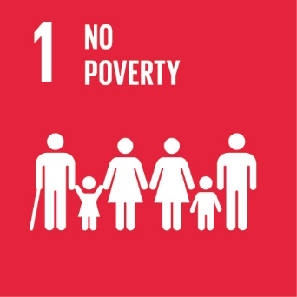 | SDG 1 aims to end poverty in all its forms everywhere  Link: SDG 1
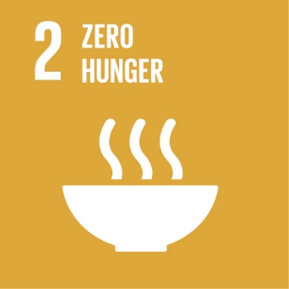 | SDG 2 aims to end hunger, achieve food security, and improved nutrition, and promote sustainable agriculture  Link: SDG 2
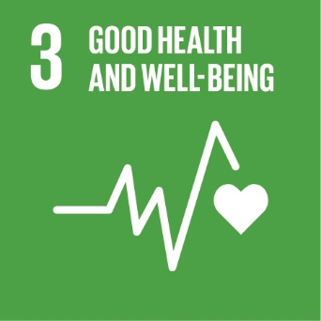 | SDG 3 aims to ensure healthy lives and promote well-being for all at all ages  Link: SDG 3
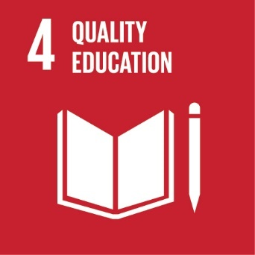 | SDG 4 aims to ensure inclusive and equitable quality education and promote lifelong learning opportunities for all  Link: SDG 4
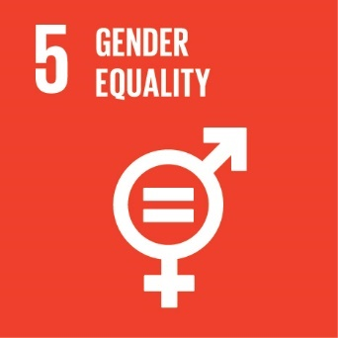 | SDG 5 aims to achieve gender equality and empower all women and girls  Link: SDG 5
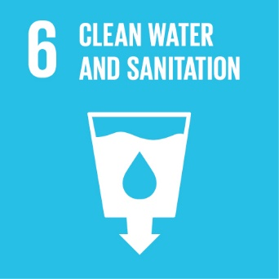 | SDG 6 aim to ensure the availability and sustainable management of water and sanitation for all  Link: SDG 6
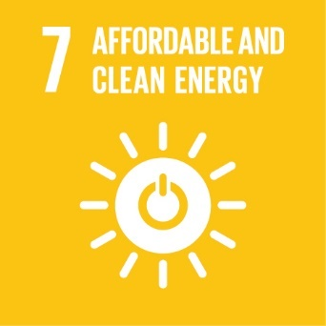 | SDG 7 aims to ensure access to affordable, reliable, sustainable and modern energy for all  Link: SDG 7
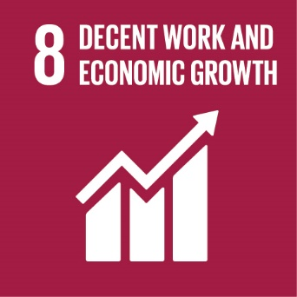 | SDG 8 aims to promote sustained, inclusive and sustainable economic growth, full and productive employment and decent work for all  Link: SDG 8
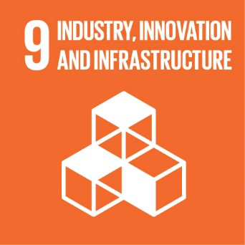 | SDG 9 aims to build resilient infrastructure, promote inclusive and sustainable industrialization and foster innovation  Link: SDG 9
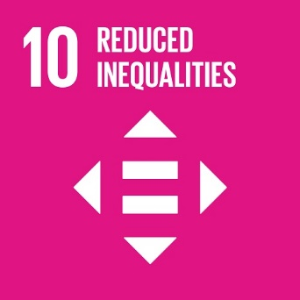 | SDG 10 aims to reduce inequality within and among countries  Link: SDG 10
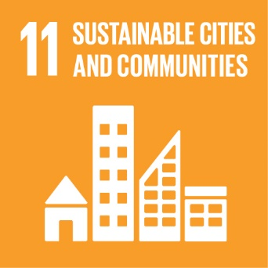 | SDG 11 aims to make cities and human settlements inclusive, safe, resilient, and sustainable  Link: SDG 11
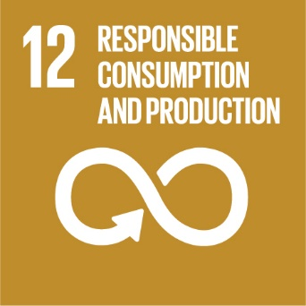 | SDG 12 aims to ensure sustainable consumption and production patterns  Link: SDG 12
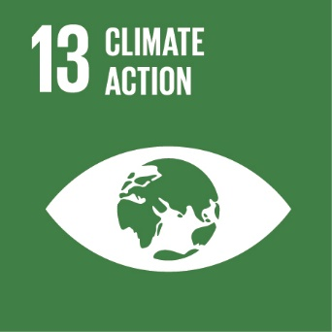 | SDG 13 aims to take urgent action to combat climate change its impacts  Link: SDG 13
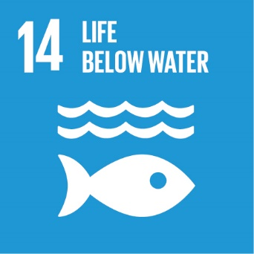 | SDG 14 aims to conserve and sustainable use the oceans, seas and marine resources for sustainable development  Link: SDG 14
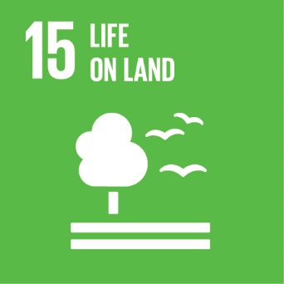 | SDG 15 aims to protect, restore and promote sustainable use of terrestrial ecosystems, sustainable manage forests, combat desertification, halt and reverse land degradation, and halt biodiversity loss  Link: SDG 15
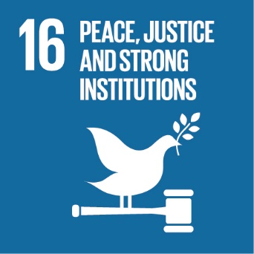 | SDG 16 aims to promote peaceful and inclusive societies for sustainable development, provide access to justice for all, and build effective, accountable, and inclusive institutions at all levels  Link: SDG 16
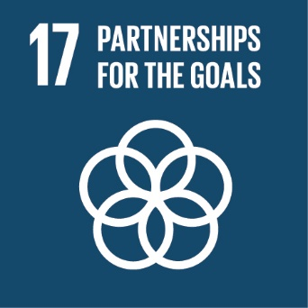 | SDG 17 aims to strengthen the means of implementation and revitalize the global partnership for sustainable development  Link: SDG 17

Teaching Activities

In the following section are a series of activities that you may wish to employ when teaching about sustainability. Sustainable development is best understood as a multi-dimensional construct, and as such teaching about sustainability is best served by emphasising the following principles:

· Inter-disciplinary elements: Students learn to appreciate the perspectives and priorities afforded by working with other academic disciplines (Tuzun, 2020).
· Trans-disciplinary elements: By working with external partners, students can develop their understanding of sustainable behaviours as multi-dimensional. It also enables students to explore viable solutions to real world issues (Di Giulio & Defila, 2017).
· A focus on experiential teaching: Whilst some benefits can be accrued from traditional teaching formats, ESD is best served by engaging students with real problems (Maher & Burkhart, 2017).
· The application to sustainable solution to real problems: The focus on solutions to real issues means that students feel empowered to make positive changes (Misseyanni et al., 2020).

The activities are broken down into ‘Beginner’, ‘Intermediate’, and ‘Advanced’ with the
following distinctions made between the categories:

· Beginner: Assumes no or little prior knowledge of the Sustainable Development Goals on the part of the students. It is characterised by the introduction of knowledge and ‘within-discipline’ activities. These activities also tend to be shorter in length.
· Intermediate: Presupposes that the students have a working knowledge of the SDGs, and consequently seeks to introduce inter– and trans– disciplinary perspectives. The majority of the activities would benefit from being completed over multiple teaching sessions, though there is some variation here.
· Advanced: Presumes that students have a strong understanding of the SDGs and are familiar with both inter– and trans- disciplinary perspectives. Activities in this category tend to be experiential in nature, emphasise the multi-dimensional, holistic nature of sustainability, and also occur over longer periods of time.

Throughout all activities there should be a focus on enabling students to feel empowered and capable of enacting positive change in the world. In addition, the activities scaffold upon each other, with the Advanced exercises presuming that your students would possess the knowledge, skills, and insights that would be developed in the Beginner or Intermediate activities.

Beginner Activities

Activity Number: 1
Name: Course Role
Detail: Students discuss what role graduates from their course would have in helping to create a sustainable society.
Session Aims: Consider relevance of their course, discuss potential and / or desired career trajectories
Teaching Time: 1 Session
Further Reading: N/A

Activity Number: 2
Name: Educational Videos
Detail: Watch TED talks, or similar
Session Aims: Gain basic knowledge on sustainable issues and exposure to core issues
Teaching Time: 1 Session
Further Reading: Biedenweg et al. (2013)

Activity Number: 3
Name: Ethics Discussion
Detail: Students discuss the ethics of sustainable behaviours, personal morality and beliefs, and social norms
Session Aims: To consider the systemic elements of sustainable behaviours at individual, communal, and the global level
Teaching Time: 1 Session
Further Reading: Biedenweg et al. (2013); Murray et al. (2014)

Activity Number: 4
Name: Group Discussion
Detail: Student or staff led discussion on the SDGs, and beliefs about them
Session Aims: Establish existing knowledge, discuss unknown SDGs

Teaching Time: 1+ Session
Further Reading: Misseyanni et al. (2020); Probst et al. (2019)

Activity Number: 5
Name: Lectures
Detail: Traditional lecture format
Session Aims: Provide basic information on sustainability, and sustainable behaviours
Teaching Time: As appropriate
Further Reading: Bielefeldt (2013)

Activity Number: 6
Name: Life Audit
Detail: Students to think about their own behaviours on a given topic (i.e., use of plastics) and make commitments to change
Session Aims: Increase awareness of their own behaviours, and promote active change
Teaching Time: 1+ Session
Further Reading: Savageau (2013)

Activity Number: 7
Name: Review SDGs
Detail: Look through the UN SDG website, discussing the goals and their current progress
Session Aims: Gain basic knowledge of the SDGs, promote discussion as to why they are important, encourage students to reflect on their capacity to address the SDGs
Teaching Time: 1+ Sessions
Further Reading: N/A

Activity Number: 8
Name: Role-play (Beginner)
Detail: Students are given a scenario, discuss the aims of each stakeholder, act out discussions between the groups, reflecting upon the motivations of each group
Session Aims: Consider different perspectives, practice working towards a consensus
Teaching Time: 1 Session
Further Reading: Misseyanni et al. (2020)

Activity Number: 9
Name: Personal Reflection
Detail: Choose an environmental goal, students to consider their personal attitudes and behaviours, and impact upon the world, discussion about changes that could be enacted, with commitment to doing so within a given timeframe
Session Aims: Encourage students to think about the relationship between their attitudes, what they say they’ll do, and what they actually do; empower students to believe they can make positive changes in the world
Teaching Time: 1 Session
Further Reading: Biberhofer & Rammel (2017)

Activity Number: 10
Name: Quizzes
Detail: Individual or group quizzes
Session Aims: To establish existing knowledge on sustainability, to promote discussion re. gaps in knowledge
Teaching Time: 1 Session
Further Reading: Misseyanni et al. (2020)

Activity Number: 11
Name: Group Voting
Detail: Discussion of SDGs or related topics, with voting as an individual or group
Session Aims: Knowledge development, student engagement
Teaching Time: 1 Session

Intermediate Activities

Activity Number: 12
Name: Analysis of a topic
Detail: Students to address a sub-issue of a particular SDG, with a focus on developing a multi-dimensional understanding of the problem
Session Aims: To develop existing SDG knowledge, with a focus on improving understanding of links with other SDGs
Teaching Time: 1 – 2 Sessions
Further Reading: Biberhofer & Rammel (2017)

Activity Number: 13
Name: Cost-benefit analysis
Detail: Students to examine a problem and its potential solutions, with a focus on the costs and benefits (both literal and figurative in each case) of the same; selection of a particular solution, with rationale for having done so
Session Aims: Promotes consideration of different perspectives and priorities within them; analysis of how each SDG has different costs and benefits associated with them; negotiating with others concerning potential solutions, development of a viable solution
Teaching Time: Multiple sessions
Further Reading: Biedenweg et al. (2013)

Activity Number: 14
Name: Case studies (Intermediate)
Detail: Students explore the issues relating to a particular set topic, with a focus on developing a multi-faceted understanding of the topic
Session Aims: Enables exploration of different perspectives and development of nuanced understandings
Teaching Time: Multiple sessions
Further Reading: Burns (2017); Bruckner & Kowasch (2019); Grose & Richardson (2016)

Activity Number: 15
Name: Debates
Detail: Students decide or are given a topic relating to sustainable behaviours to debate
Session Aims: Requires students to analyse the strengths and weaknesses of a particular argumentative position, find evidence to support that position, and consider the strengths and weaknesses of the opposing side
Teaching Time: 2 – 3 Sessions
Further Reading: Probst et al. (2019)

Activity Number: 16
Name: Earth 2.0
Detail: Thought exercise to explore positive / negative impact of removing existing phenomena or adding new ones (e.g., petrol engines never existed); discussion of merits of Earth 2.0, and potential solutions of problems re. original Earthagendas
Session Aims: Consideration of different possibilities; cost-benefit analysis; developing understanding of alternative agendas
Teaching Time: Multiple sessions
Further Reading: Bramald et al. (2015)

Activity Number: 17
Name: Inter-disciplinary teaching sessions or seminar
Detail: Any activity described in this section can also be conducted with students and staff from another Department or School
Session Aims: Enables consideration of different viewpoints, other SDGs, and produces more practical and considered solutions to issues
Teaching Time: Multiple sessions
Further Reading: Mobley et al. (2014)

Activity Number: 18
Name: Problem based learning (Intermediate)
Detail: Students given a particular sustainable problem to work on, with a focus on developing workable, nuanced solutions
Session Aims: Encourages analysis of relevant issues, evaluation of the merits of competing solutions, and development of viable actions
Teaching Time: Multiple sessions (up to one term)
Further Reading: Wiek et al. (2014); Misseyanni et al. (2020)

Activity Number: 19
Name: Ranking of SDGs for a given scenario
Detail: Students consider a particular scenario from a variety of different perspectives; discussion is given to considering the priorities of different stakeholders within the scenario
Session Aims: Considering different perspectives; evaluating potentially conflicting priorities in a situation; studying real world scenarios
Teaching Time: Multiple sessions
Further Reading: Bramald et al. (2015)

Activity Number: 20
Name: Role-play (Intermediate)
Detail: Students are given a scenario, discuss the aims of each stakeholder, act out discussions between the groups, reflecting upon the motivations of each group and what might be considered a successful resolution
Session Aims: Consider different perspectives, practice working towards a consensus, focus on understanding different definitions of ‘Sustainability’ and how this might impact upon given behaviours
Teaching Time: 1 – 2 Sessions
Further Reading: McConville et al. (2017); Misseyanni et al. (2020)

Activity Number: 21
Name: Students deliver a session on a given topic
Detail: Students are given a scenario relating to sustainability – either involving solving a particular issue or identifying future opportunities; a session (or part thereof) must be delivered, addressing those issues
Session Aims: Promotes planning, team work, identification of key issues and potential solutions
Teaching Time: 2 -3 Sessions
Further Reading: Misseyanni et al. (2020)

Activity Number: 22
Name: Town Trail
Detail: Students given particular (urban) issues to consider; development of 1st stage solutions; guided walk through town identifying problems within an applied setting; development of more nuanced solutions
Session Aims: Application of theory to problem relating to a SDG; development of potential solutions; identification of (un)anticipated problems in the real world; elaboration of solutions based on additional information
Teaching Time: 2 – 3 Sessions
Further Reading: Bramald et al. (2015)

Advanced Activities

Activity Number: 23
Name: Between Year Module Continuation
Detail: Students engage in long term projects that potentially extend over multiple years, with multiple stakeholders involved. Towards completion of the project, students identify the goals for the next stage of the project, liaise with relevant stakeholders, and prepare materials as required, etc.
Session Aims: Long-term problem-based learning, consideration of issues over extended time frames, engagement with third parties, stake holders, and other disciplines
Teaching Time: Years
Further Reading: N/A

Activity Number: 24
Name: Case Studies (Advanced)
Detail: Explore complexities of a problem, enables exploration of a real world problem, evaluate merits of competing solutions, consideration of inter- and trans-disciplinary perspectives
Session Aims: Enables exploration of different perspectives, development of nuanced solutions to problems, and implementation of solutions both within an academic context and with external partners
Teaching Time: Months
Further Reading: Biasutti et al. (2018), Burns (2017), Probst et al. (2019)

Activity Number: 25
Name: Design & Implement University Projects
Detail: In conjunction with University management, students engage in the design, implementation, monitoring, and development of University projects relating to sustainability
Session Aims: Consideration of long-term issues, negotiating with multiple stakeholders, inter- & intra-disciplinary thinking, cost-benefits analysis, engagement with applied solutions
Teaching Time: Across Year
Further Reading: Monroe et al. (2019), Trott et al. (2018), Zelenika et al. (2018)

Activity Number: 26
Name: Field trips
Detail: Working within the module, with other disciplines, or as part of trans-disciplinary learning, students work on scenarios identifying issues and potential solutions. Field trips can occur earlier in the process to identify potential issues with solutions developed in the classroom, or later on once theoretical considerations have been exhausted and require testing.
Session Aims: Consideration of real-world problems, working with external bodies, interaction with other disciplines, testing of potential solutions
Teaching Time: Variable
Further Reading: Yoon et al. (2016), Ting & Cheng (2017)

Activity Number: 27
Name: Local Government / Company Policy development
Detail: Students, in conjunction with local government bodies and companies, engage with the development of evidence-based policies that address objectives as set out by the external partner
Session Aims: Engagement with external bodies, application of theories to real world issues, consideration of different perspectives and agendas, development of workable solutions
Teaching Time: Months
Further Reading: Brundiers et al. (2010)

Activity Number: 28
Name: Problem based learning
Detail: Students identify, or are given, problems relating to multiple SDGs with an emphasis on holistic, systemic thinking
Session Aims: Inter- and Trans-disciplinary thinking, identification of potential problems, application of theories to real world issues, development of viable, realistic solutions
Teaching Time: Months
Further Reading: Biasutti et al. (2018), Guerra (2017), Sandri (2020), Wiek et al. (2014)

Activity Number: 29
Name: Project based learning
Detail: Students engage in a time limited project, with clear aims and objectives, integrated with external partners.
Session Aims: Inter- and Trans-disciplinary thinking, identification of potential problems, application of theories to real world issues, development of viable, realistic solutions.
Teaching Time: Variable
Further Reading: Biberhofer & Rammel (2017), Luederitz et al. (2016), Wiek et al. (2014).

Activity Number: 30
Name: Summit Meeting
Detail: Limited time frame activity with involvement of other disciplines and external partners, including keynote speeches, presentations, workshops
Session Aims: Interaction with stakeholders, exposure to a variety of different perspectives on an issue, applied solutions, working with other disciplines, networking
Teaching Time: Variable – 1 day event & months in preparation
Further Reading: Ha-Brookshire & Norum (2011)

Examples of Good Practice

NTU - Nottingham Business School

Members of Staff: Muhammad Mazhar & Roy Smith
Module: Transformational Leadership Development
Year of Study: Post-Graduate
Session Aims:
- Thinking about SDGs in a targeted manner
- To promote good group working practices
- To encourage students to think about their personal experiences
Session Activities:
- Talk about the SDGs
- As a group, the students choose a business sector and then identify 4 SDGS that they wish to focus on
- Their discussions focus on the following questions:
  - Why do those 4 SDGs matter to that sector?
  - What good practices currently exist regarding the SDGs and that sector?
  - What poor practices exist?
  - What recommendations might improve bad practice?
Level of Difficulty: Beginner
Teaching Programme:
- Sessions 1 – 3: Delivering content
- Session 4: Students work on posters.
- Session 5: Delivery of posters
Assessment: The module assessment is an individual presentation with questions; evidence shows that students who complete the group activity described tend to be better by comparison with those students who do not engage with it. The group assessment is a 10-minute poster presentation – if they pass, students are awarded a ‘Transformational Leadership in Practice’ certificate.
Reflections: The module has a high number of international students and this is a good exercise for enabling all students to discuss different cultural perspectives on the SDGs. Students start to reflect upon their personal behaviours, drawing comparisons with their international colleagues.
Possible changes: Change sectors or adjust the focus of the existing ones.

NTU – School of Science & Technology

Members of Staff: Petros Siegkas & Ahmed Butt
Module: Innovation & Engineering Solutions
Year of Study: Year 1– all Engineering students take the module (biomedical, electronic, sports, & mechanical)
Session Aims:
- Introduce students to engineering with an emphasis of seeing things from an engineering perspective
- Encouraging a shift in mindset using disruptive pedagogic principles
- Implementation of the CDIO frame – Conceive, Design, Implement, and Operate
Session Activities:
- Gateway 1: Weeks 1 – 2
  - Students are assigned to team by staff members.
  - Groups are allocated an object relevant to their respective discipline in engineering (e.g., portable air compressor – mechanical, blood pressure monitor – biomedical engineering, small speakers – electronic).
  - Groups start by engaging in conceptual deconstruction of the object (i.e., what is it, how do people interact with it, what is the context, what are the economics, history of, what’s the required infrastructure, and any scientific principles related to it, etc.) This is written down for submission, with any potential improvements commented upon; approval is required before they can continue to stage 2.
- Gateway 2: Week 3 – 9 (See below)
  - Physically deconstruct the object within the lab.
    - Every part must go on a board with a number and fill out a bill of materials (what is it, how much, etc.) and identify how all the parts work together.
    - Students measure all deconstructed components, and then produce 3D models on Autodesk Fusion 360 (computer aided design software).
- Gateway 3: Weeks 4 – 9 (See below)
  - Each part is considered, with an eye on how it might be improved through one of the following:
    - Reduced cost
    - Changing to improve manufacturing (speeding up or more efficient)
    - Replacement with a better part
    - Identification of being more sustainable in some capacity.

- Please note: Timings are approximate with students moving at their own speed (within reason). Students also alternate between reverse engineering and modelling sessions.
Level of Difficulty: Beginner.
Any associated assessment: Group report (summative) and presentation (formative)
Reflections: The module is important in challenging the student’s perceptions about the product from an engineering perspective, including its design, the materials used, the manufacturing process, and the sustainability of the product and its manufacture.
Possible changes: None planned at this time.

Links to Additional Resources

- Advance-HE

  - ESD in Higher Education

- EAUC – The Alliance for Sustainability Leadership in Education

  - Main Page

- European University Association

  - Environmental sustainability of learning and teaching (March 2021)

- Nottingham Trent University

  - Sustainability
    - Twitter: NTU Sustainability Team
  - Sustainable Learning
  - Green Academy
    - Twitter: NTU Green Academy

- QAA / Advance-HE Joint ESD Guidance (March 2021)

  - ESD Guidance

- A Rounder Sense of Purpose

  - Educating with a Rounder Sense of Purpose

- The United Nations

  - Sustainable Development Goals
  - UN Global Compact – The SDGs Explained for Business
  - UNESCO - Education for Sustainable Development

References

Álvarez-Suárez, P., Vega-Marcote, P., & Garcia Mira, R. (2014). Sustainable consumption: A teaching intervention in higher education. International Journal of Sustainability in Higher Education, 15(1), 3–15. https://doi.org/10.1108/IJSHE-06-2011-0044
André, R. (2020). Teaching Climate Leadership: Promoting Integrative Learning in Courses on Strong Sustainability. Journal of Management Education, 1–28. https://doi.org/10.1177/1052562920941547
Barber, N. A., Wilson, F., Venkatachalam, V., Cleaves, S. M., & Garnham, J. (2014). Integrating sustainability into business curricula: University of New Hampshire case study. International Journal of Sustainability in Higher Education, 15(4), 473–493. https://doi.org/10.1108/IJSHE-06-2013-0068
Barnum, A. J., & Illari, J. (2016). Teaching Issues of Inequality Through a Critical Pedagogy of Place. Journal of Sustainability Education, 11(February).
Barth, M., Michelsen, G., Rieckmann, M., & Thomas, I. (2016). Routledge handbook of higher education for sustainable development (M. Barth, G. Michelsen, M. Rieckmann, & I. Thomas (eds.)).
Biasutti, M. (2015). An intensive programme on education for sustainable development: the participants’ experience. Environmental Education Research, 21(5), 734–752. https://doi.org/10.1080/13504622.2014.921805
Biasutti, M., Makrakis, V., Concina, E., & Frate, S. (2018). Educating academic staff to reorient curricula in ESD. International Journal of Sustainability in Higher Education, 19(1), 179–196. https://doi.org/10.1108/IJSHE-11-2016-0214
Biberhofer, P., & Rammel, C. (2017). Transdisciplinary learning and teaching as answers to urban sustainability challenges. International Journal of Sustainability in Higher Education, 18(1), 63–83. https://doi.org/10.1108/IJSHE-04-2015-0078
Biedenweg, K., Monroe, M. C., & Oxarart, A. (2013). The importance of teaching ethics of sustainability. International Journal of Sustainability in Higher Education, 14(1), 6–14. https://doi.org/10.1108/14676371311288912
Bielefeldt, A. R. (2013). Pedagogies to achieve sustainability learning outcomes in civil and environmental engineering students. Sustainability (Switzerland), 5(10), 4479–4501. https://doi.org/10.3390/su5104479
Boca, G. D., & Saraçli, S. (2019). Environmental education and student’s perception, for sustainability. Sustainability (Switzerland), 11(6), 1–18. https://doi.org/10.3390/su11061553
Bramald, T. M., Heidrich, O., & Hall, J. A. (2015). Teaching sustainability to first year civil engineering students. Proceedings of the Institution of Civil Engineers: Engineering Sustainability, 168(2), 93–101. https://doi.org/10.1680/ensu.14.00007
Bruckner, H. K., & Kowasch, M. (2019). Moralizing meat consumption: Bringing food and feeling into education for sustainable development. Policy Futures in Education, 17(7), 785–804. https://doi.org/10.1177/1478210318776173
Brundiers, K., Wiek, A., & Redman, C. L. (2010). Real-world learning opportunities in sustainability: from classroom into the real world. International Journal of Sustainability in Higher Education, 11(4), 308–324. https://doi.org/10.1108/14676371011077540
Burns, L. D. (2017). Using the Case Study Method to Teach Sustainability in Fashion. Sustainability in Fashion Proceedings, 1–2. https://doi.org/10.1007/978-3-319-51253-2
Di Giulio, A., & Defila, R. (2017). Enabling university educators to equip students with inter- and transdisciplinary competencies. International Journal of Sustainability in Higher Education, 18(5), 630–647. https://doi.org/10.1108/IJSHE-02-2016-0030
Fisher, P. B., & McAdams, E. (2015). Gaps in sustainability education: The impact of higher education coursework on perceptions of sustainability. International Journal of Sustainability in Higher Education, 16(4), 407–423. https://doi.org/10.1108/IJSHE-08-2013-0106
García-González, E., Jiménez-Fontana, R., & Goded, P. A. (2020). Approaches to teaching and learning for sustainability: Characterizing students’ perceptions. Journal of Cleaner Production, 274. https://doi.org/10.1016/j.jclepro.2020.122928
Gibson, R. B. (2006). Sustainability assessment: basic components of a practical approach. Impact Assessment and Project Appraisal, 24(3), 170–182. https://doi.org/10.3152/147154606781765147
Godemann, J. (2008). Knowledge integration: a key challenge for transdisciplinary cooperation. Environmental Education Research, 14(6), 625–641. https://doi.org/10.1080/13504620802469188
Grose, J., & Richardson, J. (2016). Can a sustainability and health scenario provide a realistic challenge to student nurses and provoke changes in practice? An evaluation of a training intervention. Nursing and Health Sciences, 18(2), 256–261. https://doi.org/10.1111/nhs.12241
Guerra, A. (2017). Integration of sustainability in engineering education: Why is PBL an answer? International Journal of Sustainability in Higher Education, 18(3), 436–454. https://doi.org/10.1108/IJSHE-02-2016-0022
Ha-Brookshire, J., & Norum, P. (2011). Cotton and sustainability: Impacting student learning through Sustainable Cotton Summit. International Journal of Sustainability in Higher Education, 12(4), 369–380. https://doi.org/10.1108/14676371111168287
Jiusto, S., McCauley, S., & Stephens, J. C. (2013). Integrating Shared Action Learning into Higher Education for Sustainability. Journal of Sustainability Education, 5(May), 17.
Kalinowska, A., & Batorczak, A. (2015). Universities for sustainability – new challenges from the perspective of the University of Warsaw. Environmental & Socio-Economic Studies, 3(1), 26–34. https://doi.org/10.1515/environ-2015-0054
Kalinowska, A., Szkop, Z., & Wiśniewski, R. (2016). A comparative study of environmental awareness among students pursuing Bachelor’s studies in selected academic fields at the University of Warsaw, Poland. Environmental & Socio-Economic Studies, 4(2), 17–25. https://doi.org/10.1515/environ-2016-0008
Keeley, M., & Benton-Short, L. (2020). Holding complexity: Lessons from team-teaching an interdisciplinary collegiate course on urban sustainability. Social Sciences, 9(5). https://doi.org/10.3390/SOCSCI9050076
Kolb, A. Y., & Kolb, D. A. (2005). Learning Styles and Learning Spaces: Enhancing Experiental Learning in Higher Education. Academy of Management Learning & Education, 4(2), 193–212.
Lagun Mesquita, P., & Missimer, M. (2020). Supporting Engineering Students in Analysing Social Sustainability of a Product: Lessons Learned. Proceedings of the Design Society: DESIGN Conference, 1, 1755–1764. https://doi.org/10.1017/dsd.2020.266
Luederitz, C., Meyer, M., Abson, D. J., Gralla, F., Lang, D. J., Rau, A. L., & Von Wehrden, H. (2016). Systematic student-driven literature reviews in sustainability science - An effective way to merge research and teaching. Journal of Cleaner Production, 119, 229–235. https://doi.org/10.1016/j.jclepro.2016.02.005
Maher, J., & Burkhart, S. (2017). Experiential learning for engaging nutrition undergraduates with sustainability. International Journal of Sustainability in Higher Education, 18(7), 1108–1122. https://doi.org/10.1108/IJSHE-01-2016-0010
McConville, J. R., Rauch, S., Helgegren, I., & Kain, J. H. (2017). Using role-playing games to broaden engineering education. International Journal of Sustainability in Higher Education, 18(4), 594–607. https://doi.org/10.1108/IJSHE-08-2015-0146
Mezirow, J. (1997). Transformative Learning: Theory to Practice. New Directions for Adult and Continuing Education, 74, 5–12.
Misseyanni, A., Marouli, C., & Papadopoulou, P. (2020). How teaching affects student attitudes towards the environment and sustainability in higher education: An instructors’ perspective. European Journal of Sustainable Development, 9(2), 172–182. https://doi.org/10.14207/ejsd.2020.v9n2p172
Mobley, C., Lee, C., Morse, J. C., Allen, J., & Murphy, C. (2014). Learning about sustainability: An interdisciplinary graduate seminar in biocomplexity. International Journal of Sustainability in Higher Education, 15(1), 16–33. https://doi.org/10.1108/IJSHE-09-2011-0063
Monroe, M. C., Plate, R. R., Oxarart, A., Bowers, A., & Chaves, W. A. (2019). Identifying effective climate change education strategies: a systematic review of the research. Environmental Education Research, 25(6), 791–812. https://doi.org/10.1080/13504622.2017.1360842
Mulder, K. F., Ferrer, D., Coral, J. S., Kordas, O., Nikiforovich, E., & Pereverza, K. (2015). Motivating students and lecturers for education in sustainable development. International Journal of Sustainability in Higher Education, 16(3), 385–401. https://doi.org/10.1108/IJSHE-03-2014-0033
Murray, P., Douglas-Dunbar, A., & Murray, S. (2014). Evaluating values-centred pedagogies in education for sustainable development. International Journal of Sustainability in Higher Education, 15(3), 314–329. https://doi.org/10.1108/IJSHE-03-2012-0021
Otte, P. P. (2016). Integrating Sustainable Development in Higher Education through Experience-based Learning: Insights from Experts in Team (EiT) for Developing a Combined Theoretical Framework. Journal of Education for Sustainable Development, 10(1), 131–159. https://doi.org/10.1177/0973408215625550
Pauw, J. B. de, Gericke, N., Olsson, D., & Berglund, T. (2015). The effectiveness of education for sustainable development. Sustainability (Switzerland), 7(11), 15693–15717. https://doi.org/10.3390/su71115693
Probst, L., Bardach, L., Kamusingize, D., Templer, N., Ogwali, H., Owamani, A., Mulumba, L., Onwonga, R., & Adugna, B. T. (2019). A transformative university learning experience contributes to sustainability attitudes, skills and agency. Journal of Cleaner Production, 232, 648–656. https://doi.org/10.1016/j.jclepro.2019.05.395
Pujol, F. A., & Tomás, D. (2020). Introducing sustainability in a robotic engineering degree: A case study. Sustainability (Switzerland), 12(14), 1–24. https://doi.org/10.3390/su12145574
Remington-Doucette, S. M., Connell, K. Y. H., Armstrong, C. M., & Musgrove, S. L. (2013). Assessing sustainability education in a transdisciplinary undergraduate course focused on real-world problem solving: A case for disciplinary grounding. International Journal of Sustainability in Higher Education, 14(4), 404–433. https://doi.org/10.1108/IJSHE-01-2012-0001
Ritchie, M. A. (2013). Sustainability Education, Experiential Learning, and Social Justice: Designing Community Based Courses in the Global South. Journal of Sustainability Education, 5(May). http://www.susted.org/
Rowe, D. (2007). Education for a Sustainable Future. Science, 317(July), 323–324.
Sandri, O. (2020). What do we mean by ‘pedagogy’ in sustainability education? Teaching in Higher Education, 0(0), 1–16. https://doi.org/10.1080/13562517.2019.1699528
Savageau, A. E. (2013). Let’s get personal: Making sustainability tangible to students. International Journal of Sustainability in Higher Education, 14(1), 15–24. https://doi.org/10.1108/14676371311288921
Ting, D. H., & Cheng, C. F. C. (2017). Developing pro-environmental behaviour: ecotourism fieldtrip and experiences. International Journal of Sustainability in Higher Education, 18(7), 1212–1229. https://doi.org/10.1108/IJSHE-03-2016-0052
Trott, C. D., Weinberg, A. E., & McMeeking, L. B. S. (2018). Prefiguring sustainability through participatory action research experiences for undergraduates: Reflections and recommendations for student development. Sustainability (Switzerland), 10(9), 1–21. https://doi.org/10.3390/su10093332
Tuzun, U. (2020). Introduction to systems engineering and sustainability PART I: Student-centred learning for chemical and biological engineers. Education for Chemical Engineers, 31, 85–93. https://doi.org/10.1016/j.ece.2020.04.004
Wiek, A., Xiong, A., Brundiers, K., & van der Leeuw, S. (2014). Integrating problem and project-based learning into sustainability programs: A case study on the school of sustainability at Arizona state university. International Journal of Sustainability in Higher Education, 15(4), 431–449. https://doi.org/10.1108/IJSHE-02-2013-0013
Yoon, T. K., Kim, S., Takano, T., Yun, S. J., & Son, Y. (2016). Contributing to sustainability education of east asian university students through a field trip experience: A social-ecological perspective. Sustainability (Switzerland), 8(10). https://doi.org/10.3390/su8101067
Zelenika, I., Moreau, T., Lane, O., & Zhao, J. (2018). Sustainability education in a botanical garden promotes environmental knowledge, attitudes and willingness to act. Environmental Education Research, 24(11), 1581–1596. https://doi.org/10.1080/13504622.2018.1492705

