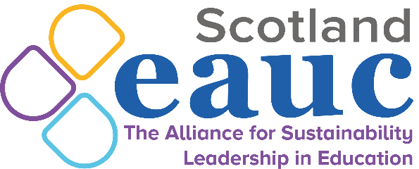
Date: 28th April 2021
Time: 14:00 – 15:30
Venue: Virtual

Travel and Transport TSN -28th April 2021
14:00 | Welcome and Introductions  Trudy Cunningham, Convenor, University of Dundee
14:05 | Business travel flight emissions and policies – a time of opportunity?  Siôn Pickering - SRS Projects Coordinator, University of Edinburgh; Network Manager: Roundtable of Sustainable Academic Travel  With institutions expected to set Scope 3 emission targets as of 2022, the impacts of Covid-19, and an increasing awareness from senior managers of the financial, ecological and reputational risks within internationalisation, is this an opportune time to change travel behaviours with regards to flying?
14:25 | Engaging with local authorities on sustainable travel  Sustrans  Scottish Government is increasingly focussed on the place-based agenda for tackling climate change, with funding going through community planning partnerships/city deals - how can institutions best engage through these processes to create positive change for sustainable travel?
14:45 | Break
14:50 | Campus funding mechanisms for sustainable travel  Group discussion  With many institutions using income from car parking as their main funding for active travel, how are institutions looking to fund active travel initiatives in the coming academic year?
15:10 | Lockdown travel trends  Group discussion  Following the rise of homeworking/virtual learning and active travel through 2020, has this trend been sustained this semester and are institutions reimagining how people access campus services in the middle-term?
15:25 | AOB  All
15:30 | Thanks and close  Trudy Cunningham, Convenor, University of Dundee

*We will keep the meeting open after the meeting as an opportunity for further discussion and networking.

