Covid19 Impact Survey – Conducted in November 2020

We at EAUC wanted to better understand how the pandemic impacted the sustainability community and how we can better support members during these difficult times. A sustainable, resilient recovery is possible and the recent Covid-19 Impact Survey aimed at EAUC educational members revealed that in the context of the disruption caused, over 60% of respondents believe that despite the barriers, there are opportunities to advance sustainability within institutions. The full analysis of the survey is available below:

EAUC Educational Members Key Contacts |  | All other educational contacts
1. Please indicate what is the approximate total budget available for delivering on sustainability within your institution. Include your own salary, salaries of others tied to budget(s) you control, supplies and services. This excludes standard operating budgets (i.e. energy, waste)
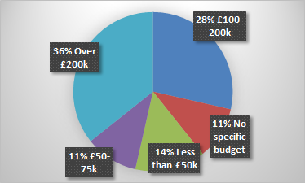 |  | N/A
2. As a direct result of the COVID-19 pandemic, what are your expectations for the budget available for sustainability for the academic year 2020-21, compared to the 2019-20 academic year?
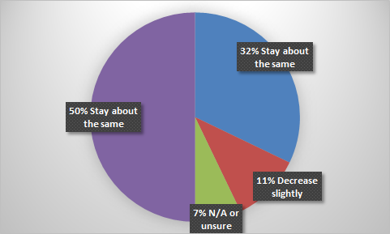 |  | 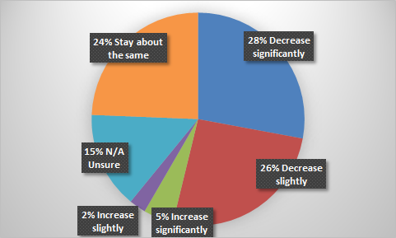
3. Given the disruption caused by the COVID-19 pandemic, do you see opportunity or threat to advancing sustainability within your organisation?
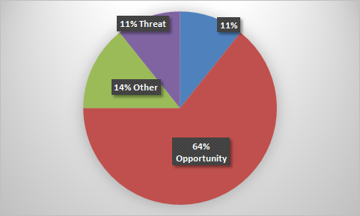 |  | 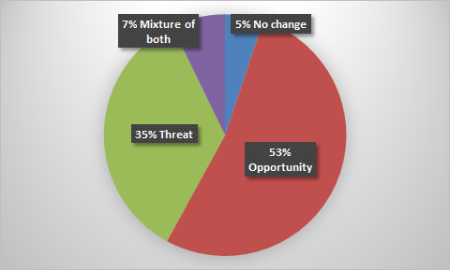
4. Considering the impact of the COVID-19 pandemic on your institution, how confident do you feel in your ability to lead on your institution’s sustainability agenda?
Very confident – 23%  Confident – 38%  Somewhat confident – 35%  Not confident – 4%  Not confident at all - N/A |  | Very confident – 20%  Confident – 32%  Somewhat confident – 35%  Not confident – 10%  Not confident at all – 3%
5. At present, has the number of sustainability staff positions changed at your organization?
No, positions have remained the same -all answered |  | No, positions have remained the same – 95%  Yes, increase in positions – 5%
6. The pandemic also represents an opportunity to build back better and we want to make sure that you receive the appropriate support from EAUC to successfully reach key sustainability targets. Please indicate the type of support you consider would be more useful for your department/institution to receive from EAUC?
6.1 Tailored guidance on how to meet your net-zero targets | Extremely useful - 65%  Useful - 28%  Less useful - 7% | Extremely useful – 58%  Useful – 30%  Less useful – 10%  Not at all useful – 2%
6.2. Assistance with using the Sustainability Leadership Scorecard to better show institutional progress | Extremely useful - 28%  Useful - 28%  Less useful - 35%  Not at all useful - 7% | Extremely useful – 22%  Useful – 50%  Less useful – 21%  Not at all useful – 2%
6.3. Support material (guides, events, webinars, etc.) on how to implement sustainability-related projects within own institution | Extremely useful - 28%  Useful - 28%  Less useful - 35%  Not at all useful - 7% | Extremely useful – 32%  Useful – 38%  Less useful – 20%  Not at all useful – 10%
6.4. Investment in your and your team’s leadership skills | Extremely useful - 25%  Useful - 42%  Less useful - 28%  Not at all useful - 5% | Extremely useful – 35%  Useful – 46%  Less useful – 10%  Not at all useful – 9%
7. Please add any other information you think would be helpful for EAUC to know about the impact of COVID-19 on your organization’s sustainability efforts. THEMES
- Important to keep leaders focused and establish more contact with exec staff to appreciate how the climate crisis can have an effect on the organisation  - EAUC important in terms of resources & support network, but institutions have a clear tough ride ahead  - Be sensitive to costs, as budgets are being restricted |  | Help us keep our heads above water. academics are drowning in a sea of 'new measures'.  - Guidance on how to make sustainability a priority in initial teacher education and leadership!  - Single-plastic agenda to continue to push it  - Ideas sharing and case studies on how to implement positive change  - Communication is key - assistance with developing an effective comms strategy  - Opportunities are available, but staff morale (budget reductions, staff reduction, furlough, etc) can be very low, so a focus on wellbeing and active support is needed  - Risk to overlook the EAUC offering with the growing pressure on the ground  - Concerns regarding disconnect with an absent student population
8. Comments regarding the disruption caused by Covid19 THEMES
- Sustainability continues to be prioritised but resource allocation unlikely to change  - Risk that although sustainability is embedded in the Strategic Plan with limited anticipated resources (money & people) it will be considerably harder to deliver  - Overall thinking that better save today than investing in long term carbon & energy saving  - Blended learning can be taken forward beyond Covid and push on benefits of home working |  | - Potential lack of focus on sustainability-related activities from leadership  - Anticipated funding will be more difficult to secure and budget diverted elsewhere  - Virtual/online teaching presented opportunities for the institutions to review their policies and procedures (WFH, reduced travel, green restart)  - Opportunity to integrate climate awareness and sustainability engagement activities at staff & student level  - Increase in energy usage (ventilation, wider space usage, use of chemicals)  - Positive outlooks where Sust. Strategy lead sits on the executive board  - Step back on a series of measures taken to stop single-use plastic  - Pandemic and rapid uptake of technology have disrupted HE  - Threats to long term planning

Overall considerations and data limitations
- On average, budgets for sustainability are within 100-200k (and over) 64%, but this is only 34% of the total number of members (KC), therefore the data has little representation;
- Budgets for 2020-21 are expected to stay the same for most Key Contacts - 50%, however, it is a growing anticipation among some Key Contacts - 32% and more acutely for the rest of members that budgets are expected to decrease significantly/slightly - av. of 30%; it is also visible throughout the themes of the survey;
- Despite the growing concern caused by potential axed budgets, the vast majority of respondents - over 60% consider that the whole situation caused by the pandemic can also represent an opportunity for the sector, so this is an area that should be explored further;
- As a whole, respondents feel confident about their abilities to lead on their institution’s sustainability initiatives; some particular concerns that should be addressed further are those related to members who have indicated their acute concerns that emanate from the overall situation within their institutions;
- In terms of future resources, tailored guidance on how to meet net-zero targets is the most indicated type of support that EAUC can offer and this is reiterated throughout - (203 out of 226 respondents);
- The results re SLS usage/usefulness is anticipated for the wide range of educational members (179 to be very useful;
- Regarding support materials (new and/or updated) the educational members benefit greatly from these and should be a core aim in 2020-21;

