Climate Risk Register Tool User Guide

Introduction
EAUC Scotland have taken Adaptation Scotland’s ‘Tool 4 - Climate Risk and Opportunity Assessment Workbook’ (Excel Tool) and accompanying ‘Tool 4 – Climate Risk and Opportunity Assessment Workbook Handbook’ (Word Document) and modified both to be more tailored to the Further and Higher Education (FHE) sector. The original tools were produced by the Adaptation Scotland programme in collaboration with Climate Ready Clyde, and included input from University of Strathclyde. Please do keep checking in with the Adaptation Scotland programme after the publication of this document, as they are the subject experts and will be updating and evolving their resources as time goes on.
As this tool was developed initially for use at Borders College, it is recommended that institutions add in any additional risk categories relevant to their institution. This could include, but is not restricted to: research, international activities, offsetting/insetting activities, investments etc. Please let us know how you adapt the tool and we will make relevant updates when the next review is scheduled.
This document is a step-by-step guide on how to use the Climate Risk Register tool. Please also see our video by Rory Hill (Sustainability Project Manager for the Central and South Scotland College Partnership) on how he used the tool at Borders College.
For technical queries, please contact EAUC Scotland at scotland@eauc.org.uk or the Adaptation Scotland programme at: adaptationscotland@sniffer.org.uk.

Contents
Climate Risk Register Tool User Guide 1
Introduction 1
Vulnerability (Impact) (Tab 2) 2
Exposure (Likelihood) (Tab 3) 3
Risk Register (Tab 4) 4
Action Plan (Tab 5) 6
Weather Incident Log (Tab 6) 6
Campus Flood Risk (Tab 7) 7

Version 1, November 2023
re

Vulnerability (Impact) (Tab 2)
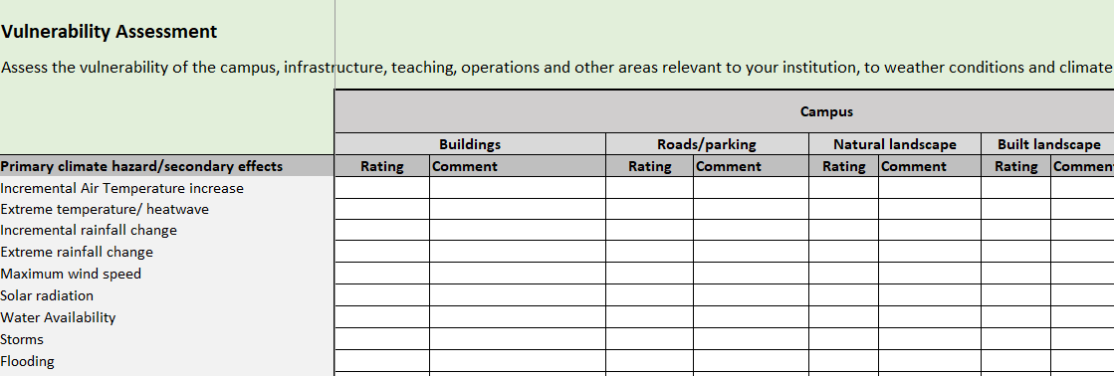
Assess the vulnerability of the main elements of your institution (campus, infrastructure, teaching, operations and other areas relevant to your institution) to weather conditions and climate change.
The vulnerability assessment involves systematically assessing the degree to which the main elements of your institution (campus, infrastructure, teaching, operations and other areas relevant to your institution) are sensitive or susceptible to disruption or damage from a range of hazards, climatic conditions and secondary effects, as well as the size, scale and scope of disruption.

For each of the main elements of your institution (campus, infrastructure, teaching, operations and other areas relevant to your institution), consider the extent to which they are sensitive to each climatic variable or secondary effects, and score them appropriately. This is a subjective process, and can be an individual judgement or as a result of discussions with key members of the relevant department. Make sure to add any variables missing or exclude any variables that are not relevant for your institution. As a guide, the different ratings are set out below:

- High vulnerability: Climate variable/ hazard may have significant impact on campus, infrastructure, teaching and operations.
- Medium vulnerability: Climate variable/ hazard may have slight impact on campus, infrastructure, teaching and operations.
- Low Vulnerability: Climate variable/ hazard has limited/no effect.

Notes: This template has been developed for Borders College. There may be more factors that are relevant for your institution e.g. coastal erosion. Add any relevant climate impacts from the drop-down menus on extra rows.

Exposure (Likelihood) (Tab 3)
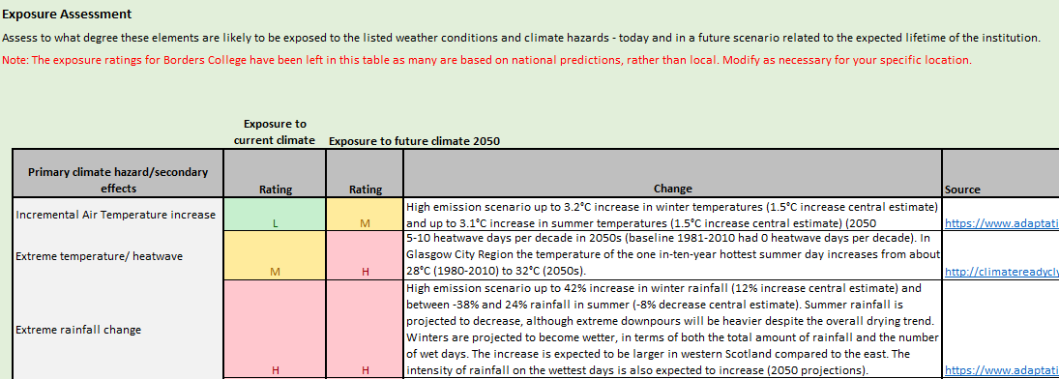
Assess to what degree these elements are likely to be exposed to the listed weather conditions and climate hazards - today and in a future scenario related to the expected lifetime of the institution.
Work through the worksheet to rate the institution's overall exposure to each climate hazard or secondary effect under current climatic conditions, scoring them as Low, Medium or High. Then repeat the assessment for exposure to future climatic conditions. In each case, make sure to document the data sources used for the assessment or any notes or assumptions made.

Assessing whether your site is exposed to climate conditions requires you to seek out information from trusted sources to inform your assessment. Some key national sources of information are:

- SEPA flood extent maps (using 1 in 200 year return period for now, 1 in 200+CC for future, or 1 in 1000) for surface water, river, coastal and groundwater flooding.
- Dynamic Coast for future risk of coastal erosion.
- The UK Climate Projections 2018 – Land projections and Sea Level Rise projections.
- You may also be able to use local climate change risk assessments. For Glasgow City Region, Climate Ready Clyde published a thorough assessment of climate risks and opportunities in 2019.

Wherever possible you should also consider site-specific conditions such as low-lying areas that could be prone to surface water flooding and areas with a high degree of paving that may become urban heat islands. Use expertise local to your institution to determine this (e.g. your Estates team).

Note: Localised data is best but you may have to settle for national data. More localised data should be released in the coming years. Look out for new datasets coming out to update with more localised data.

Risk Register (Tab 4)
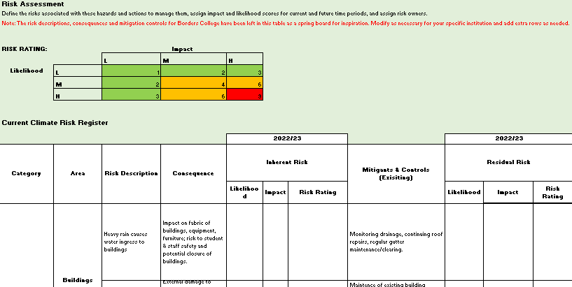

Completing the Risk Register is a two-stage process, which consists of assessing risks under the current and future climate.

- Completing an assessment of climate risks for the current climate
Start by listing all the institution-specific risks that might arise from the most significant climate risks identified. For each risk, you will need to complete:

- Risk description - including the cause of the risk (weather condition), the event and its effect on the institution.
- Consequences – a description of the possible consequences as a result of the risk occurring (these could be financial, reputational, operational).
- Inherent risk scores – this is the likelihood and impact of the risk, without any treatments or controls in place to manage them.
- Mitigants and controls (existing) – the existing activities your organisation has in place to reduce the likelihood of a risk occurring or to reduce its impacts.
- Residual risk scores – the overall score once mitigants and controls are taken into account.

- Assessing future climate change risks

Once you have completed the current climate risk register, you will need to consider how climate change will affect the overall future risk. For each risk, include a short narrative on how climate change may affect it. Then you should work through to score risk likelihood and impact for inherent risks and residual risks under climate change.

- Climate Change Risk Modifier – how climate change will modify the risk as described.
- Future risk scores –The likelihood and impact of the risk in the future climate (without any of the mitigants and controls from the baseline period).
- Filling the adaptation gap - Actions your organisation could take now and in future to strengthen existing mitigants and controls and to further reduce residual risk.

Suggested steps to complete the risk register:
- Fill in your best estimates for the current risk section.
- Review this first draft with college/university staff (this could be in a workshop style setting) and finalise once these have been completed.
- Fill in your best estimates for future risks.
- Repeat review with staff, then update and finalise.
Notes:
- The previous steps (Vulnerability (tab 2) and Exposure (tab 3)) should be used as a guide to inform the risk register and do not need to be followed strictly.
- Real experience from college and university contacts is vital to sense check the risk register by bringing in specialist knowledge. You are not expected to know the risks for every institutional department.

Action Plan (Tab 5)
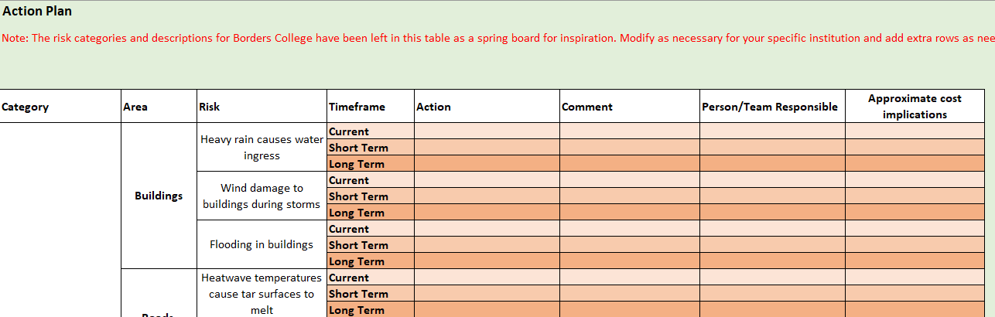
Creating a plan for action, given the results of the risk register.
Current actions, short-term and longer-term actions, broken down by risk categories.
There is room to add extra columns to account for projected costs etc. Try to make the action plan as SMART (Specific, Measurable, Achievable, Relevant, and Time-bound) as possible.

Weather Incident Log (Tab 6)
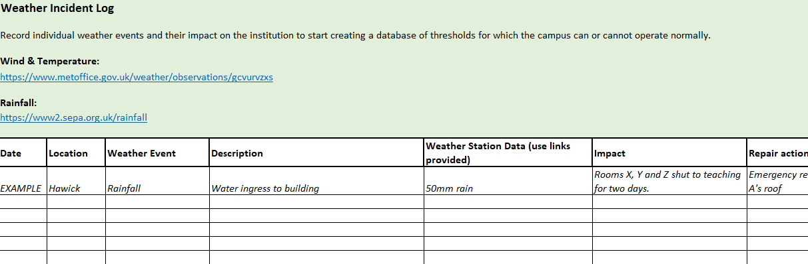
The Weather Incident Log is intended to be a place to record weather events and their impacts as they are experienced by an institution. This information can then be reviewed and used to improve the risk register and other projections, based on real world experience.
As well as noting the occurrence of weather events which cause disruption, the Weather Incident Log offers the opportunity to record details of the severity of the weather event (e.g. windspeeds or rainfall), to help establish a baseline of what weather events an institution can or cannot tolerate.

Campus Flood Risk (Tab 7)
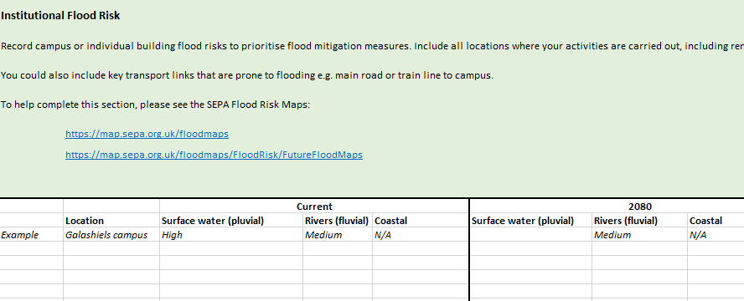
This tab includes links to SEPA resources for assessing flood risk and includes a specific table to record this.
Use this to plan flood mitigation measures either on your institution’s estate, or through working with local landowners to improve mitigation measures on their properties that directly affect your institution’s land.

