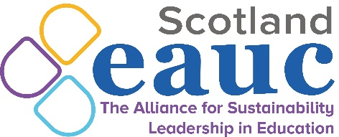

EAUC-Scotland Autumn Forum

13th September 2022 9.30am – 11.30am

9.30 | Welcome and Introductions  Christine Calder, Dundee & Angus College and EAUC-Scotland Convenor
9.40 | Benchmarking Against the FE Roadmap  Rory Hill, EAUC-Scotland
10.00 | Green Gown Award Case Study: A Climate Justice Focus On Gender And Mental Health (Diversity, Equity & Inclusion in Sustainability)  Professor Tahseen Jafry, Glasgow Caledonian University
10.20 | Relaunch of Sustainability Leadership Scorecard; EAUC project update  Fiona Goodwin, EAUC
10.40 | Comfort Break
10.50 | Overview of 2023+ programme proposal  Matt Woodthorpe, EAUC-Scotland
11.10 | AOB  Christine Calder, Dundee & Angus College and EAUC-Scotland Convenor
11.30 | Thanks and Close  Christine Calder, Dundee & Angus College and EAUC-Scotland Convenor

