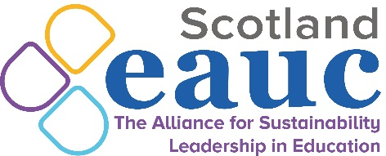

EAUC Scotland Autumn Forum

15th November 2023 1-3pm

1.00 | Welcome and Introductions  Christine Calder, Dundee & Angus College and EAUC Scotland Convenor
1.10 | Place-based responses to sustainability: UHI Moray’s Just Transition Project  Dr Christine Anderson & Dr Kerry McInnes, UHI Moray
1.25 | Place-based responses to sustainability: West Lothian College’s ECOHOUSE  Steven Morrison, West Lothian College
1.40 | Place-based responses to sustainability: Q&A and group discussion  Christine Calder, Dundee & Angus College and EAUC Scotland Convenor
1.55 | Comfort Break
2.05 | Progressing ESD alongside estates: University of Strathclyde  Scott Strachan & David Charles, University of Strathclyde
2.20 | PBCCD Statutory Guidance Update and Discussion  Matthew Woodthorpe, EAUC Scotland
2.50 | AOB  Christine Calder, Dundee & Angus College and EAUC Scotland Convenor
3.00 | Thanks and Close  Christine Calder, Dundee & Angus College and EAUC Scotland Convenor

