transition
university of st andrews

Report of workshop supported by
EAUC Topic Support Network: Promoting Positive Behaviour and Transition: University of St Andrews

Monday 18th October 2013
University of St Andrews 10.30am – 12:-00pm webpage

Attendees:
Eilidh | Sinclair | University of Stirling
Laurelin | van der Molen | Stirling Students Union
Georgina | Stutchfield | University of St Andrews
Tucker | Diego | University of St Andrews
Joshua | Miska | University of St Andrews (student)
Rehema | White | University of St Andrews
David | Stutchfield | University of St Andrews
Lorraine | Corbett | Heriot-Watt University
Alistair | MacLeod | Transition University of St Andrews
Hanna | Plant | EAUC- Scotland
Laura | Mazza | Recent graduate of Edinburgh and Bologna

Summary

This workshop was jointly convened by the EAUC Topic Support Network (TSN) on Promoting Positive Behaviour and Transition: University of St Andrews. The discussion reflected Transition type responses to community mobilisation as well as more formal community engagement approaches. Issues discussed were as follows:
- Our roles and mandates in engaging university communities
- What is a ‘community’, and can we think of our own Universities as communities? How do we go about recognising and understanding the community we are working with?
- The application, understanding and use of behaviour change theories. How they differ and how we use them to help assist and direct our own projects for sustainability and positive change.
- How theories can support what we do and whether models like the transition model can be helpful as guidance.
- Language used in mobilising communities, behaviour change efforts and sustainability.
- Capitalising on making the business case to help drive sustainability projects. What this means and how it can be done.
- The wording and phrases used such as ‘behaviour change’ and (in focus), what should this TSN be called?
- Achieving practical action- reflection on what motivators we have in our own lives?

The following minutes are an account of those discussions, the further questions examined and what this can do to help find direction for community engagement and promoting positive behaviour projects in Scotland’s universities and colleges. They should be read with reflection on your own projects or initiatives.

1. | Welcome and introductions  Welcome and introduction from Rehema White, University of St Andrews.  This meeting relates to the EAUC TSN but is also an opportunity for Transition University of St Andrews to reflect on and share with others the activities and outcomes from a THRIVE Transition training weekend. It also ties in with the work of the new organisation/network Learning for Sustainability Scotland.  Welcome and introduction from Hanna Plant on EAUC Scotland. This meeting is also a chance to keep the EAUC network alive and to bring people from outside together; and to reflect on the future direction of that TSN.  Introduction to Transition University of St Andrews from Alistair MacLeod:  Transition University of St Andrews launched in 2009. It was not initially funded by CCF but later received funding and is now funded in a 3 year programme. It currently has 5 projects funded under CCF plus other activities all aimed at bringing the university community into closer contact with the local community:  - Carbon Conversations - facilitated sessions with staff and students and wider community.  - Carbon Footprint tool (University focussed),  - Edible campus (University owns 300 hectares of land so opportunities to grow food, community growing alongside students too),  - Local Exchange Project: An economic project looking at trying to create a local exchange trading system (alternative currency) each trade is equivalent of a pound worth of services or goods.  - The Cook Smarter project, getting people to create more with food.
2. | Our Multiple Roles:  An interesting mix of people present and demonstrative of the effect of CCF on the sector. We asked each other what role we played, whether this was a job or a volunteer role, what motivates us, who ‘decides what we do’ and whose targets we have to meet.  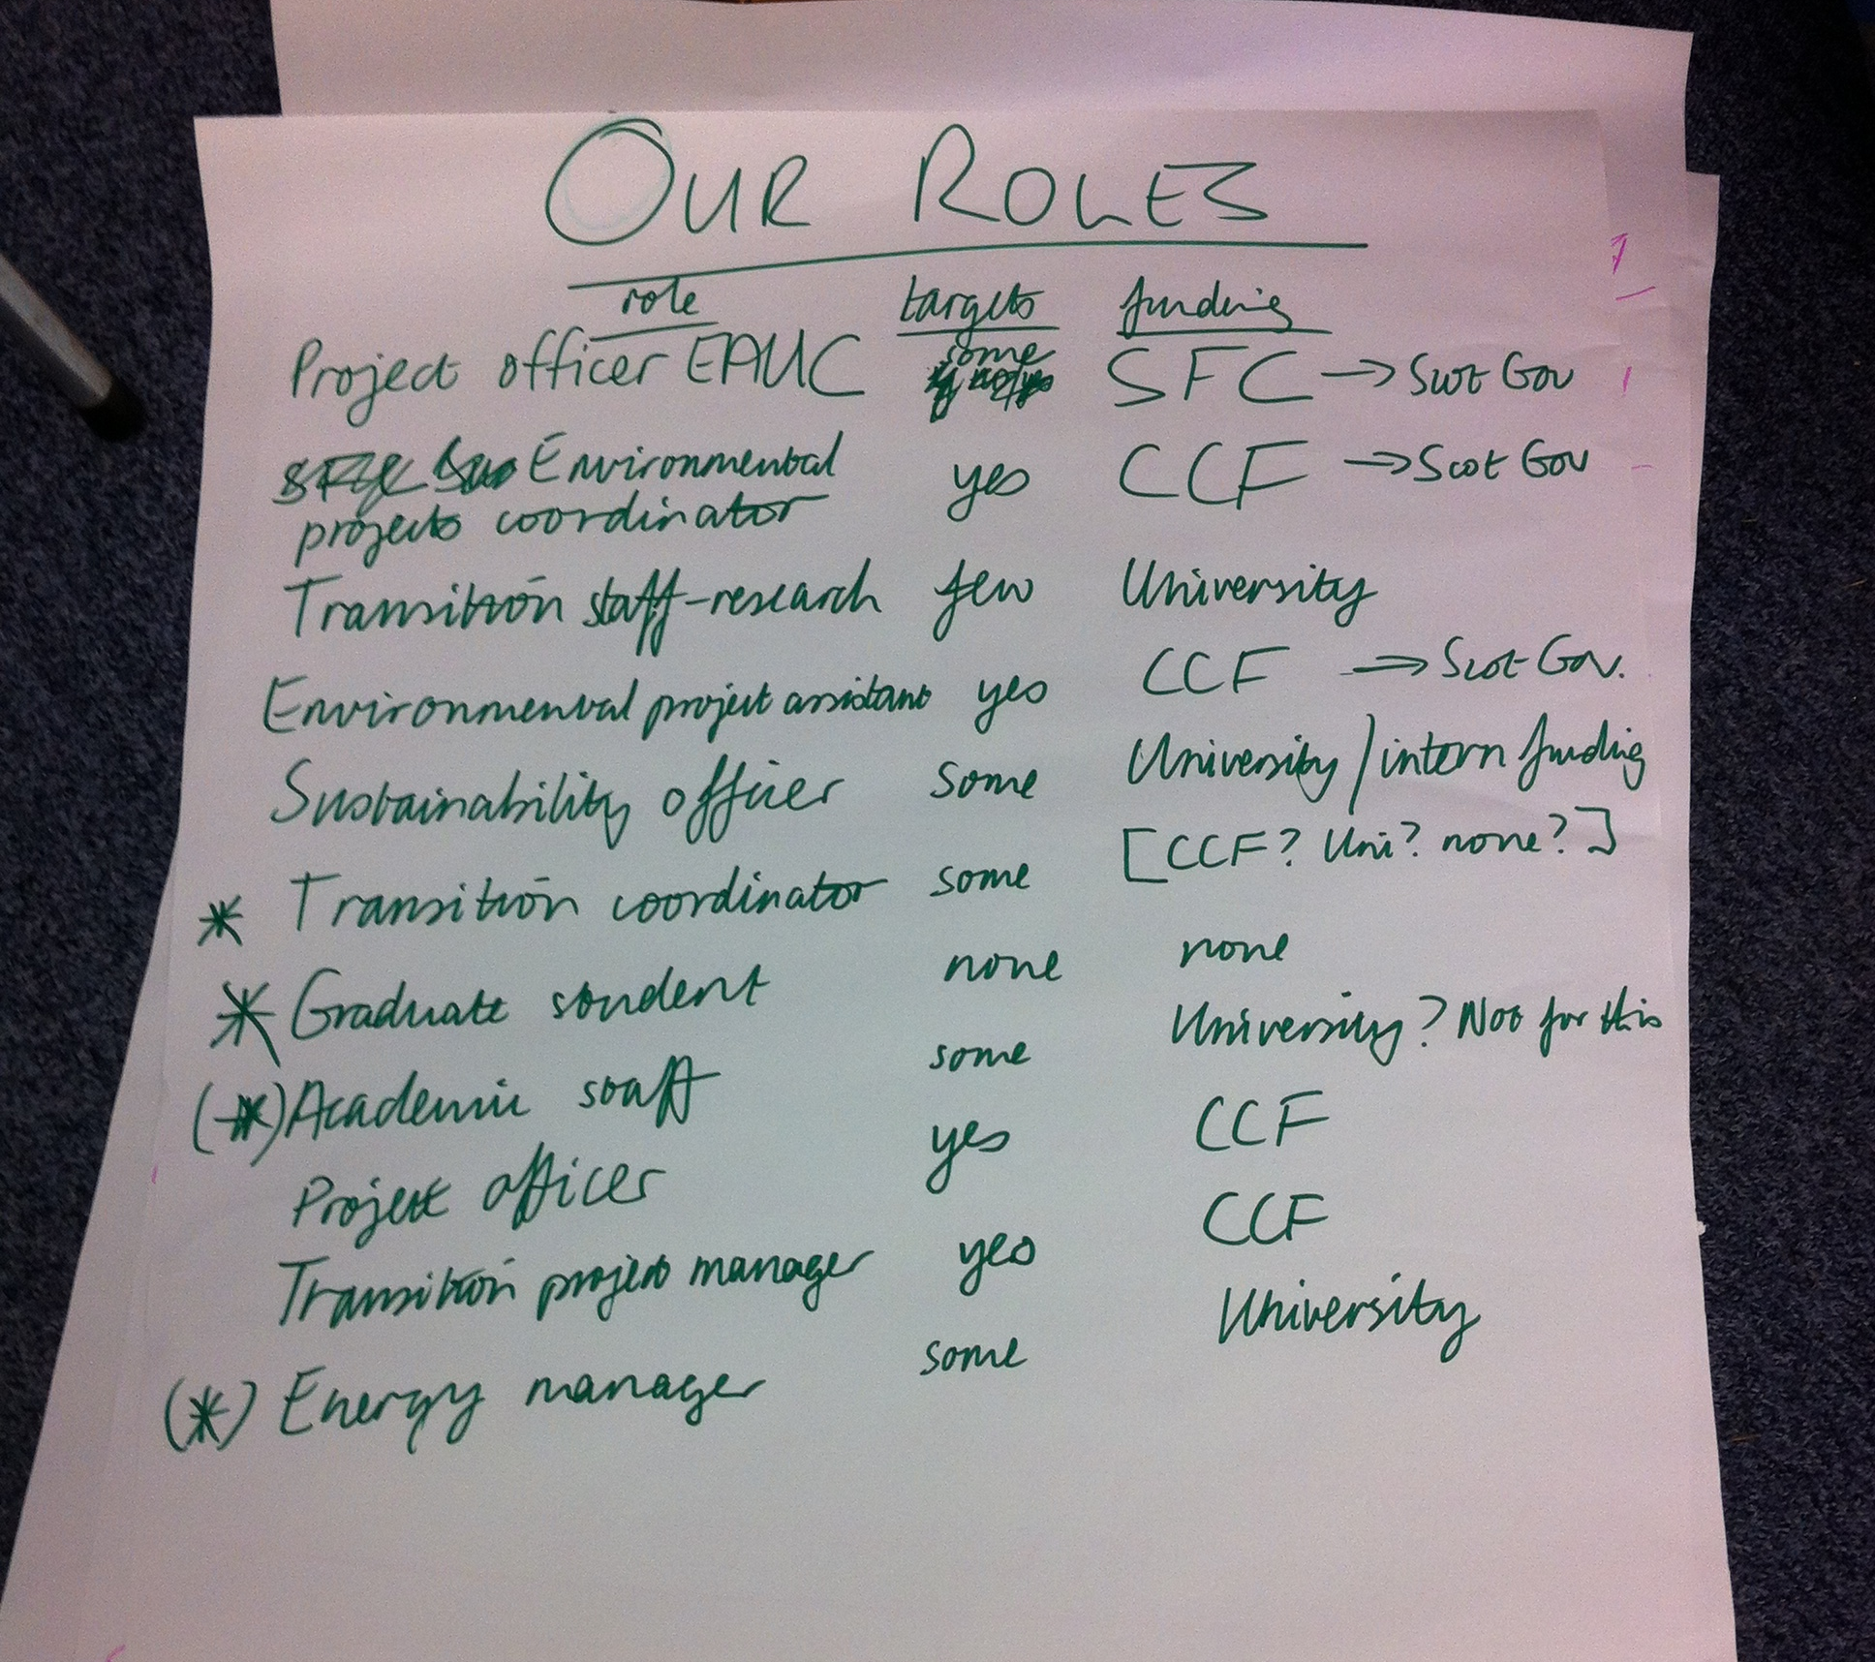  Exercise- Mapping other important roles in this picture:  Examples included senior management, academic staff, more students, funders themselves, NUS, HEA, HEFCE, Scottish Government reps, community members, other NGO’s i.e. RES, Transition Network, Student Unions, operations staff and estates.  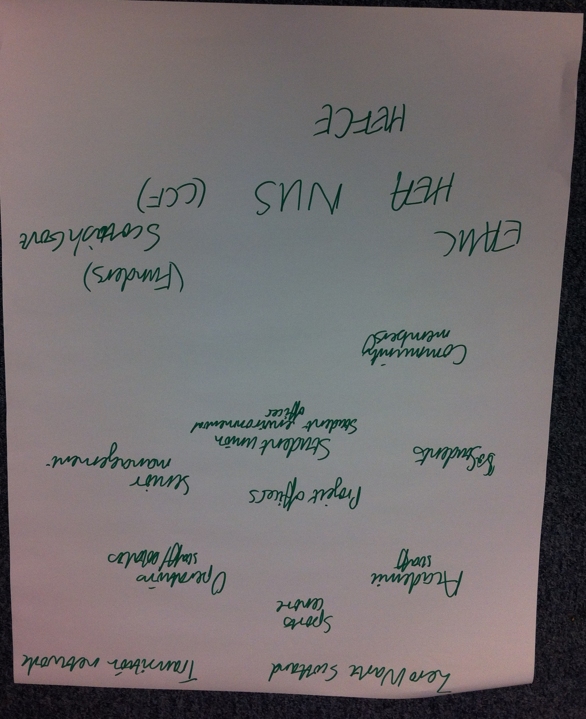  There is not a very clear bottom-up or top down system, it’s much more complex. There is also quite a temporary nature to activities happening due to reliance on funding. Difficulty there for community mobilisation as that requires time, long term commitment, and building relationships.  Key question- Who are we doing this for? Who is our audience? An important question to consider for any project.
3. | University as Community (see hand-out).  What defines a community? This is a contested concept. Communities of place, practice, interest, values can be identified. Community is both and an aspiration of sustainability as well as a pathway towards it. If we have community, we may feel a greater sense of place, sense of identity, have more agency and thus travel towards sustainability. The two go hand in hand.  We compared sustainability projects at our own and other institutions, and concluded that the more people came together as a community, the more positive action resulted. Creating community goes beyond isolated activities. However, whilst sustainability enthusiasts are needed on the ground governance and structures are also required to support progress.  A University acts as a community but also as a business. There is a sense that universities are moving more toward students as clients rather than education in the form of fulfilling the potential of individuals and contributing to a better society.  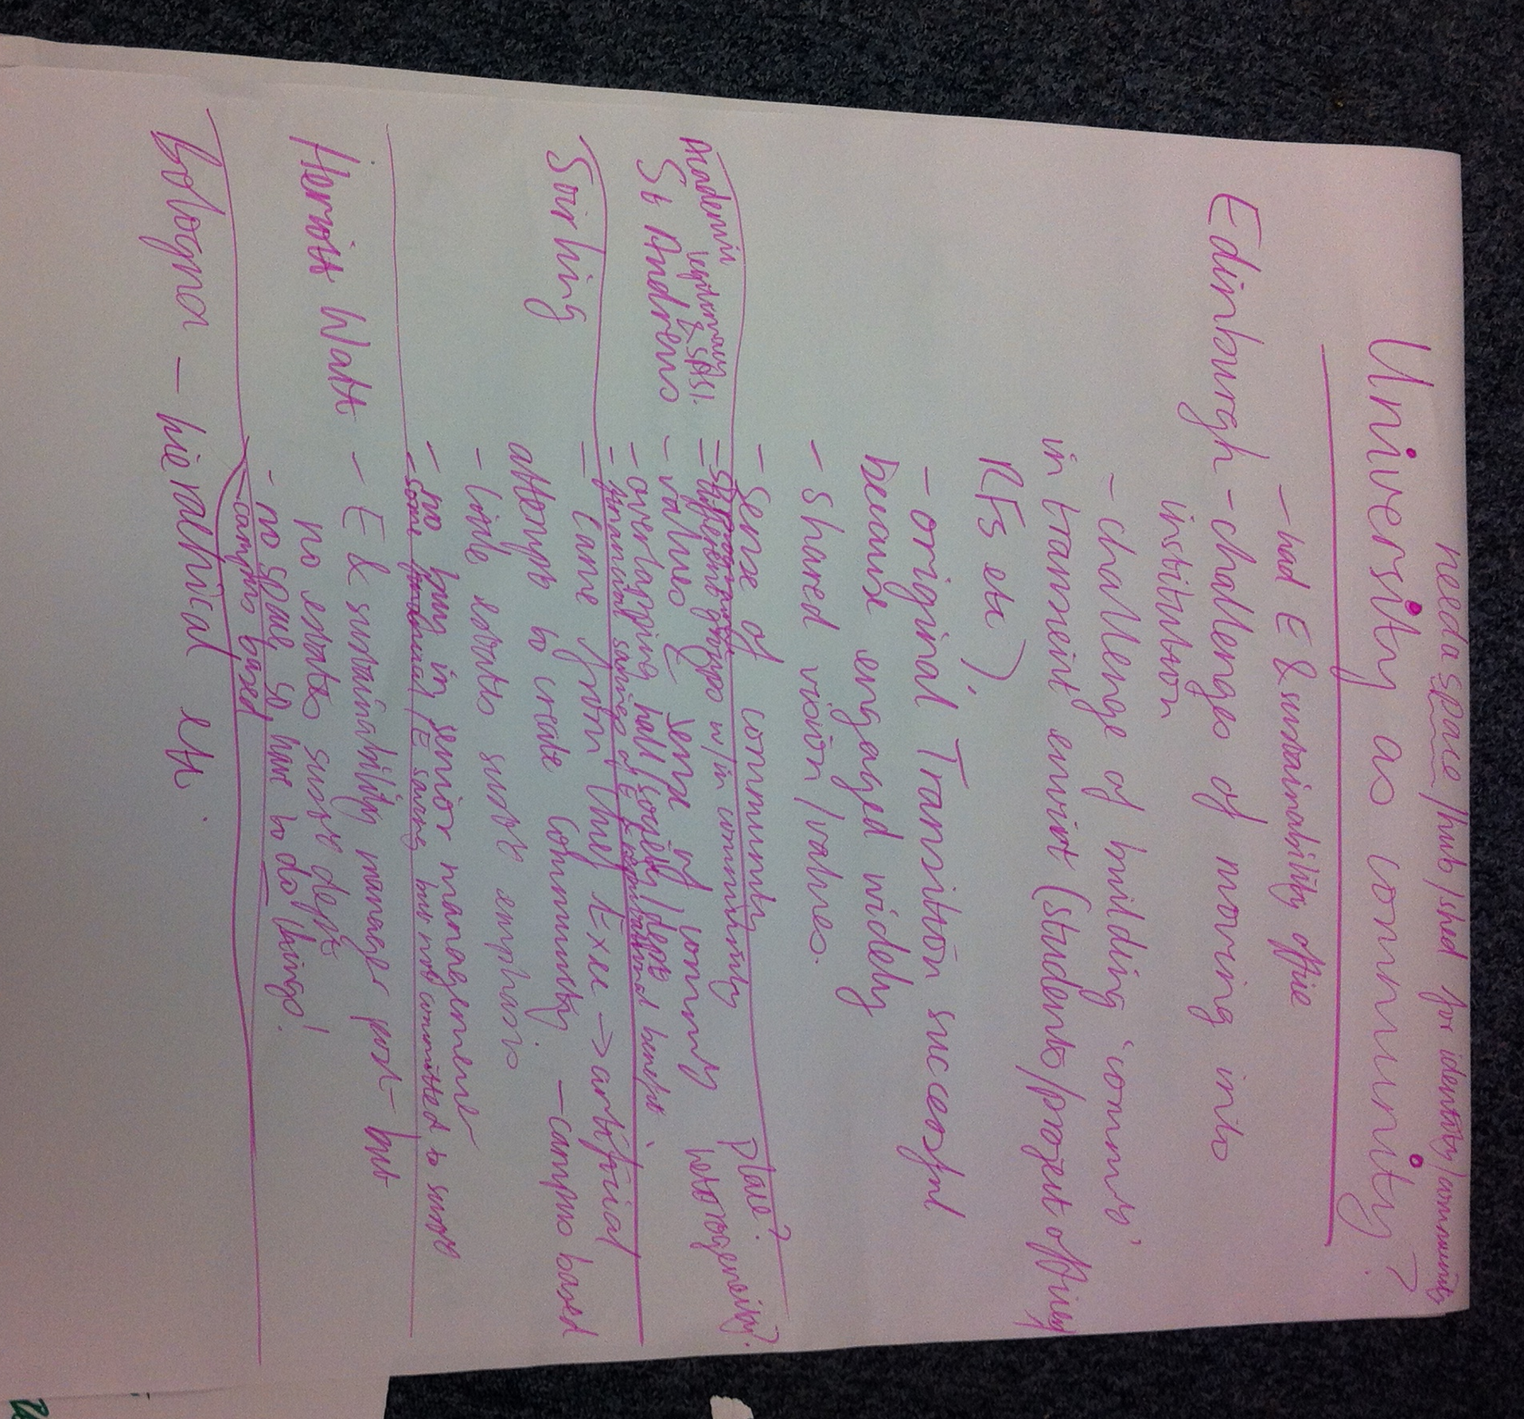  Although many of the participants were employed to engage communities and promote sustainability behaviours within their institutions, all were strongly motivated by their values.
4. | Group Discussion  Question: For sustainability, can we capitalise on social responsibility and the business agenda or/and can we capitalise on the form of ‘community’ at universities to create positive results/ action?  Group 1- Looked at the Universities of Edinburgh and St Andrews and compared the different challenges they face. The challenges of building community in such a transient environment, for students, staff and funding. Community is about forming relationships, creating identity and maintaining partnership. Having a sense of core values and mission holds community together. At the University of Stirling, by contrast, the impetus for community engagement has come more from top down so it feels almost like they are forcing the community to mobilise around sustainability when the community willingness from bottom-up isn’t quite there yet.  Group 2- There’s quite a lot of layers of over-lapping societies and other organisations and institutions, such as halls. These are not the same for all universities. Sub communities are based on different aspects of life, such as food, sport. At Heriot-Watt University there is no sustainability office, it is not as integrated so it’s difficult to find a senior buy in base through which to support and drive community sustainability efforts.  HEA survey- indicates 80% of students want sustainability to be part of their academic studies.  Group 3- sustainability projects done well can make financial sense and even financial returns; the business case is there. University of St Andrews has based some aspects of their progress on establishing that business case and capacity has been built on the business case with respect to energy costs. Engagement targets have been built on student experience which is a big part of the University’s commitments. How do you connect these issues to the core commitments of the institution? Back to the importance of finding a shared objective, vision and mission. Where a shared objective cannot be found, community groups can feel a lot of objection and resistance from senior management at a university.  Group 4- Every university has to think about community in a different way. The way in which community can then grow is different and where it ends up and what keeps it alive is different. Group 4 looked at the university community and the town as a place. You have to approach people about where they are from and the surroundings they came from. Have to engage people with a link to their halls and something they relate to. Creating a space where communities can meet, socialise and community is crucial to keeping communities active and alive. Community gardens, student halls, these meetings are all examples. Heriot-Watt struggles as they do not have such a space. Keele University has a great example of space creation for community mobilisation- student bungalow. However they also have an active academic programme driving it forward. Loughborough put up a shed for an event and then didn’t take it down, then people started using it for skill share, arts and then it became this space where people would meet. Stirling being campus based, definitely sees issues as a place rather than community of interest. Being on campus the community of place is the halls but then you can’t connect so much with local community.  Stirling have a big problem as the most engaged staff often leave to go to other more active groups like Edinburgh or St Andrews. Question- how to you protect smaller communities and smaller mobilisations?  Another difficulty is finding an identity or name that works. People don’t like ‘behaviour change’ as sounds negative or ‘community mobilisation’ as sounds too military.  If you don’t start from grassroots, how do you then mobilise community if the mass energy isn’t already there? Do things always have to start from the grassroots? Or can you work effectively mobilising community from inside the institution.  Communicating ‘the business case’ is important in being able to communicate across institutions and across identities but need to maintain values base.
6. | Discussion on Theories of Behaviour Change presented in Doppelt theories handout:  3 keys to successful climate protection and sustainability efforts:  First Key: Know the stages of change of your target group and match change mechanisms to those stages.  Second Key: Build both tension for change and efficacy.  Third key: Building efficacy emphasise the benefits of sustainability practices in the early stages and the downsides to the later stages of change.  Three theories on behaviour change- see hand-out. Also see document: ‘Climate Communications and Behaviour Change: a guide for practitioners’. A good document but very much for American audience.  See 5 stages of change for Climate Protection and Sustainability (hand-out).  - Disinterest  - Deliberation  - Design  - Doing  - Defend.  First 3 stages are somewhat invisible so difficult to get a sense of where people are and how healthy your community mobilisation is at the early stages. We tend to assume that people only change behaviour when they are actually doing it. Events are crucial to engaging people at the point when they are considering what they can do and what activities they can adopt. Language is crucial to making an activity positive. It’s about designing events and processes to allow for people to be engaged during transitional stages of changes. Our attitudes form our behaviours. How do we thus change attitudes? Values must shift before behaviours do.  People change because social norms change. How do you keep up with changing social norms to make desired behaviour ‘normal’? Big question- which theories are useful for each of us at the moment?
5. | Discussion- how do these theories inform and support what we do? Is the transition model useful? How could/ would transition run?  Question of what language and strategies we use. The theories can help support language and get that language right for the community that you are working with; and can help us develop overall strategies. Communication is key. These are good theories to use as checklist when putting events together. We can see a virtuous cycle of action strengthening sustainability values that in turn enhance further action. Key thing is to appeal to the values you want to change and in a way that people understand. How do you incentivise without offering a shiny fancy prize?  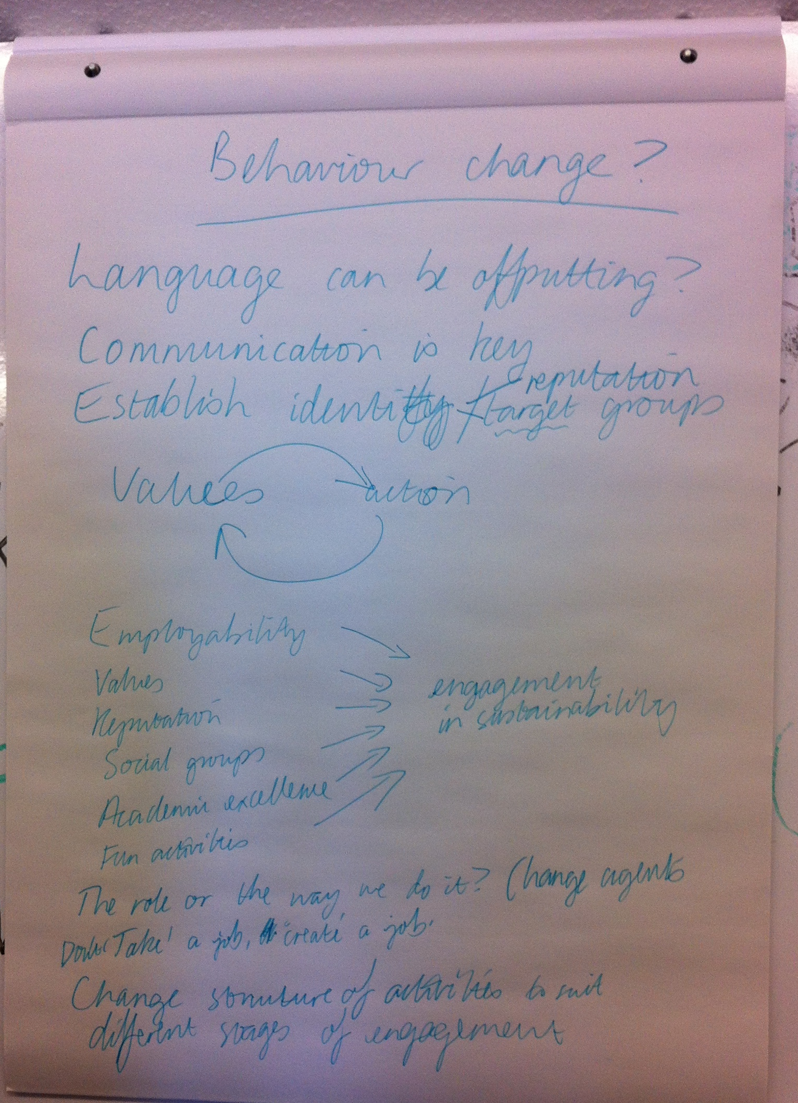  Positive, culturally specific use of language  St Andrews for instance recently run a competition for the best ‘green costume’ for Raison Weekend. The prize was a free meal at a local restaurant. Thus, also building on the sense of local community. They had some excellent submissions and lots of people got involved.  Rewarding by ‘stroking the ego’ and celebrating e.g. NUS green impact is a useful approach. However, to make that impact significant, people need to recognise the efforts and achievements of sustainability work. Tucker (St Andrews) is putting together a package for staff green champions. How do we provide that reward? (financial? Celebratory?). The financial award for the Inter-hall Energy Competition at St Andrews is funded by Residential and Business Services from the cost savings made by keeping energy consumption under control in the halls. They want to also get halls to take more ownership of this- come up with new ideas to compete and bring the competition to life. Problem with that comes back to the community mobilisation element.  It is important to be on the ground and see what people are doing. Think out of the box. It’s a challenge to have a strategy and have targets e.g. CCF, whilst also trying to engage with people since individual people are not ‘strategized’. Finding the connection of satisfying both. Green champions are also so important in mobilising people and creating norms. When does something become a norm?  For students it’s often about social groups; but also relates to the reputation of the university; and also to employability, graduate attributes, skills and the promise of job opportunities; and we must emphasise critical reflection and the pursuit of academic excellence.  Employability and sustainability connection can be pushed too far. HE and FE institutions can feel like cogs in an economic machine churning out students into an unsustainable world. It’s not just about getting a job and getting more money. In fact, HE should be about fulfilling your potential and as an individual and as a member of society. You can take up a job but work according to your values. In HE we feel pressure to tick all the employability, graduate attribute etc boxes, yes we have to make it legit, but looking at actual roles can be different to how people actually work. Employability and sustainability can be made into a good link. Change agents UK is one example. The idea of not just taking a job but creating a job is also an appealing aspect and those stories are good to tell i.e. sustainability officer role at St Andrews. We always need to see opportunities, think positively.  So, to think about the future, how can we build capacity for people to keep going through those stages in the theories, and achieve the ‘doing’ stage? How are we in a prime position to attract people who are at the questioning stage? In many ways, they are outsiders looking in. If peers engage them its much more attractive. If they can see people like them ‘doing’ it becomes easier to engage them. Engage with each other and engage with sustainability.  At the University of St Andrews, staff engagement became an objective within staff induction training.
Discussion on the title of this Topic Support Network:
Tension of calling it behaviour change. Is that moral? Why change?
Whose behaviour change? Is it moral to impose another view on a community? Should this TSN be called ‘critical reflection’ for instance? Universities buy into critical reflection as a recognised skill and this is an important skill for sustainability and the sector at large. For Rehema, the WWF work on values is fascinating. People have to be allowed to identify and find their values before they can take sustainability seriously. This can make universities a challenging place to engage as so many people are still forming those values and exploring their freedom to find their values.
Universities have an obligation to be leaders in society and shape societal direction. There is a lot of critique that universities are not doing this.
Crucial also to measure the outcomes of outreach programmes. Institutions will ask for outcomes. How do you give people flexibility whilst also monitoring change? Has it actually made a difference to them? How do you go about monitoring a value change?
Problems of doing a sustainability action with the wrong values. This is a big risk for any programme. Sustainability actions may be taken, but is with the right motivations?

6. | Achieving Practical Actions in our specific areas  We discussed the personal challenges of supporting sustainability within our institutions. There was a recognition to promote personal resilience for ourselves, and learning how to to work with opposing factors. We all need to recognise and enable whatever nourishes us and keeps us going and functioning.  Eilidh- coming to event like this with people who are facing similar issues a real boost.  Personal stories are very important. If we can work with our personal stories it can make a huge difference. Speaking to other people is very important; not feeling alone; bringing people together.  What keeps Joshua going is engaging with the people who are not at this meeting; ‘normal people’ who don’t think deeply, don’t reflect on the bigger issues, just get on with life and what they want. We need to understanding their motivations or lack thereof as well as why we feel so comfortable with what we do. We need to engage with the mainstream.  For Rehema, nature connection is also important. A recent course supporting nature connection run by the new organisation Nature Culture Scotland helped inspire her.  David- has a sense that ‘the system is out to get you’! It’s a fascinating challenge to make it work for you at all times; to achieve sustainability.  Tucker- really values these kinds of discussions but what really keeps him going are the hands on practical things that he can do. Building up the feeling that he is succeeding in some aspects of what he wants to achieve and building the confidence to tackle the bigger issues.  Georgina- taking note of achievements is really important and keeps her going. Without wanting to get tied up in a mountain of report writing, trying to remember the meaningful stuff of what’s been done, beyond recording figures.  Celebrating success is a great way to finish.  Core question: what keeps you going? What motivates you to strive for positive change towards sustainability?  Conclusion:  It was agreed that the discussion had been interesting and useful, and that the opportunity to discuss and meet others was useful as well as particular outcomes.  FIELDTRIP  The group then walked to see one of the University hall community gardens, at Albany Park. The process of setting up and gaining permissions was discussed, as well as more practical exchanges of tips such as how to access good compost.  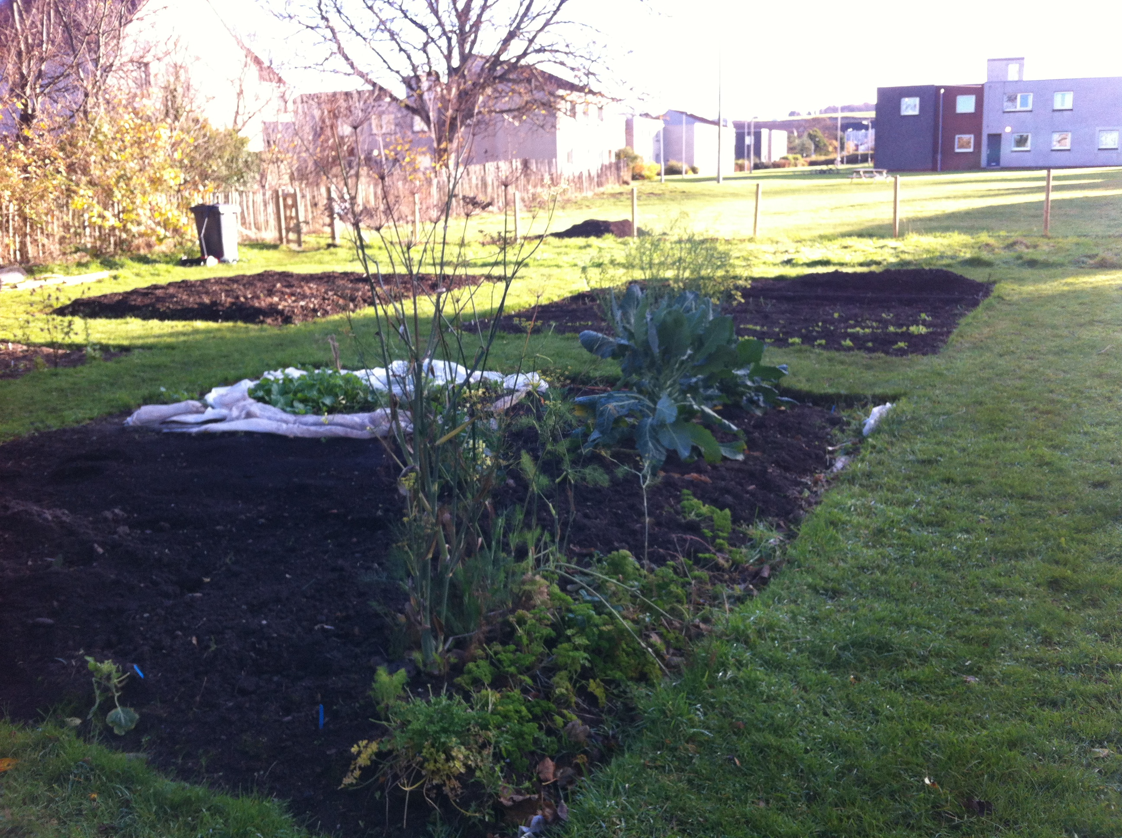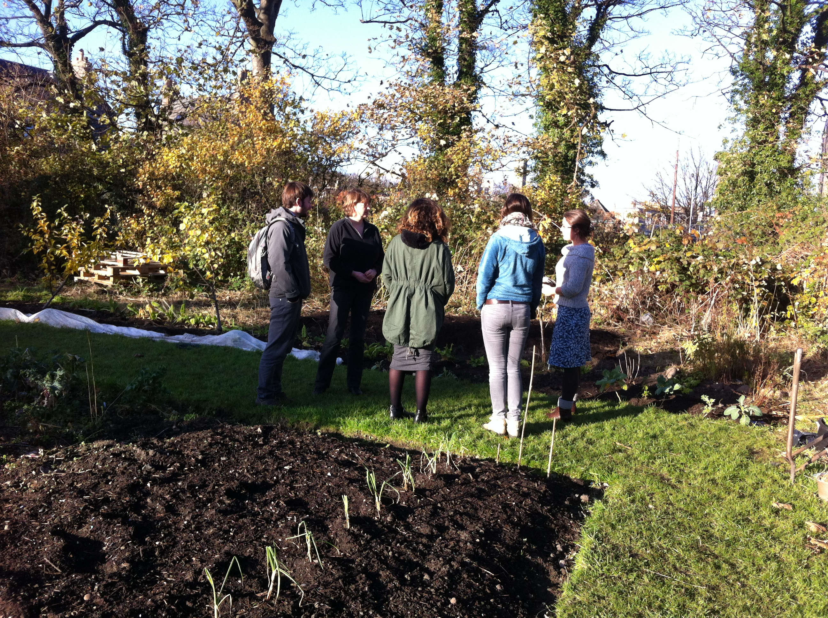  Student garden at Albany park
7. | Books recommended:  - ‘Handbook of Sustainability Literacy: Skills for a Changing World’. Ed. Arran Stibbe (2009)  - ‘Principles of Sustainability’ by Simon Dresner (2002)  - ‘Methods for community participation, the complete guide for practitioners’ by Somesh Kumar (2003)  - ‘The Transition Handbook: from oil dependency to local resilience’ by Rob Hopkins (2008)  - ‘The Sustainable University: progress and prospects’. Ed. Stephan Stirling, Larch Maxey and Heather Luna. (2013)  - ‘Kitchen Table Sustainability: practical recipes for community engagement with sustainability’. Ed Wendy Sarkissian et al. (2008)  - Climate communications and behaviour change: a guide for practitioners’. By Cara Pike, Bob Doppelt and Meredith Herr. (2010)  - White, R.M. and Harder, M. (2013) The Journey towards Sustainability via Community: Lessons from two UK universities. Chapter in The Sustainable University: Progress and prospects. Ed. Sterling, S., Maxey, L., Luna, H. Abingdon: Routledge.

