Introduction

1.1 This paper outlines support available from Keep Scotland Beautiful (KSB) in understanding and using a behaviour change framework to assist development and delivery of public sector carbon emission reduction plans and programmes.

2. Context

2.1 The Scottish Government recognises that behavioural factors are of critical importance in ensuring Scotland’s successful transformation to a low carbon nation. “Understanding the role of behaviour and decision-making in achieving targets and influencing accordingly” is one of 5 cross-cutting themes comprising government strategy on meeting emission reduction targets, as set out in RPP2.

2.2 RPP2 highlights the Low Carbon Scotland: Behaviours Framework (March 2013) which draws on the latest behaviour change research to establish a strategy for encouraging the Scottish population to embrace low carbon living. RPP2 states that:

“The Individual, Social and Material (ISM) approach, combined with ten insights for effectively influencing behaviours, will help the government and others to build stronger policies and programmes to meet the challenge of changing the way we live, work and travel.”
Para 3.5.2, RPP2

3. Objectives

3.1 KSB is funded by the Scottish Government during this financial year (2014-15) to promote awareness of the Low Carbon Scotland: Behaviours Framework (LCBF) and to provide support to public bodies in understanding and using ISM (see annex for overview of ISM); specifically in the exercise of their duties under Part 4 of the Climate Change (Scotland) Act 2009 and particularly in relation to climate change mitigation.

3.2 KSB has incorporated the Low Carbon Behaviours (LCB) work into the Sustainable Scotland Network (SSN) programme. SSN supports the public sector in understanding and implementing their climate change and sustainability duties including reporting on Scotland’s Climate Change Declaration. Other relevant KSB programmes and activities are also drawing on the LCB framework, in particular, the ISM approach e.g. Eco-schools and the Climate Challenge Fund.

3.3 The main objectives of LCB are to:

  - Pilot the ISM approach with a cross-section of public sector organisations and partnerships to develop action plans. The action plans will ideally feed into new and existing carbon reduction initiatives e.g. climate change strategies, active travel plans, energy efficiency measures etc.;
  - capture learning from the ISM pilots including production of case studies that illustrate how the tool has been used in different contexts, challenges and opportunities;
  - monitor and evaluate the impact of ISM including progress with implementation and integration of action plans into relevant initiatives.

3.4 ISM can be applied internally or in partnership with other public, private and/or voluntary sector organisations. Partnership approaches are of particular interest to help understand the potential for ISM to promote innovation and channel collective efforts on behaviour interventions to reduce carbon emissions at a local or regional scale.

4. ISM Support Options

4.1 Organisations can choose from a range of support including:
- an initial presentation providing an overview of the ISM approach and methodology;
  - a taster session to explore and scope potential use as an organisational tool (2 Hrs);
  - a workshop for up to 12 people to develop an action plan to address a specific issue (1/2 day);
  - mentoring and advice on action plan development and integration (dependent on needs);
  - using ISM as a desktop planning and/or evaluation tool.

4.2 To register for ISM support please contact June Graham (see below) or complete the survey at https://www.surveymonkey.com/s/LFW35WN

5. Contact and Further Information

5.1 If you would like to discuss any aspect of the above please contact:
June Graham
Sustainable Development Officer (Low Carbon Behaviours)
June.graham@ksbscotland.org.uk
01786 468785

Annex: Overview of ISM

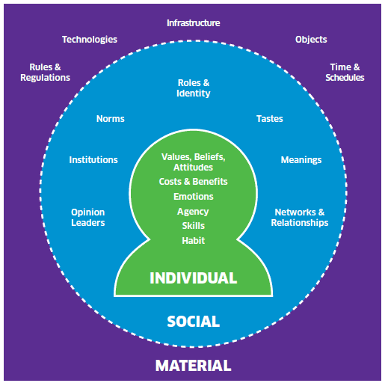
- ISM provides a simple, pragmatic approach for policy-makers and practitioners seeking to influence behaviour change. It is based on social science theory, practice and evidence which shows that behaviour is influenced by three contexts. Briefly, these are:

  - The individual context which focuses on people’s values, attitudes and skills together with other factors which drive our choices and actions;
  - The Social context which recognises that individuals are strongly influenced by others and what society considers to be appropriate and desirable behaviour; and
  - The Material context which represents the external “environment” such as infrastructure, rules and regulations and how these promote or constrain our behaviours.

- A key benefit of ISM is that by considering all three contexts together more significant and long-lasting change will be achieved, as opposed to conventional behavioural approaches which often target only one context, for example awareness campaigns.

- ISM is best applied in a workshop setting but may also be used as a desktop planning or evaluation tool. Critical stages involve mapping and linking existing issues, constraints etc. against relevant factors within each I, S and M context; identifying priority factors and insights; identifying gaps and capturing ideas to formulate a coherent programme of actions.

- The Scottish Government has been using ISM to improve the development and delivery of new and existing policies, in particular to support RPP2. ISM workshops and case studies to date include:

  - How to increase uptake of electric vehicles which has informed Switched on Scotland: A Roadmap to Widespread Adoption of Plug-in Vehicles;
  - How to encourage walking for short journeys – involving Transport Scotland, Health Scotland, Paths for All, Living Streets Scotland and Sustrans, outputs informed the National Walking Strategy.
  - An Energy Savings Trust research project using the ISM approach to investigate and better understand how to increase uptake of solid wall insulation.

- Resources and further information:
  - The ISM User Guide explains the tool, its use in a workshop plus some case studies;
  - An accompanying Technical Guide provides more background and detail on the different ISM factors that influence people’s behaviours.
  - Both guides plus other reports concerning the Low Carbon Behaviours Framework are available at http://bit.ly/1aJAwtz.

Second Report on Proposals and Policies, Low Carbon Scotland, Meeting the Emissions Reduction Targets 2013-2027, The Scottish Government, June 2013

