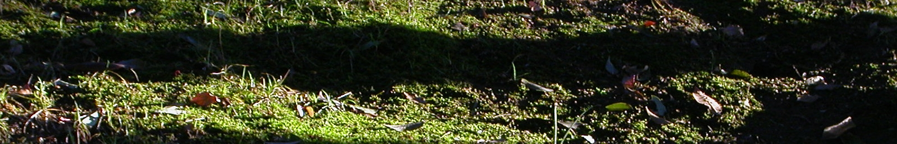

21 November 2008
University of Gloucestershire,
Cheltenham, No charge

Name:

Address:

Email: Phone:

Following the Soundings in Sustainability event, participants will be invited to write short chapters for a book entitled The Handbook of Sustainability Literacy to be published by Green Books. The core chapters of the book will describe specific skills, values and attributes which can help learners adapt to the changing conditions of the 21st century, in ways which contribute to a more sustainable society. There will also be some more general chapters which critically examine the concept of sustainability literacy. Please indicate which sustainability skill/capacity/attribute you would like to focus on, or, if you would rather write a general chapter, then please give a brief description of your initial ideas. Final versions of all chapters (max 2000 words) are due on the 1 February 2009. For more information, including detailed instructions for authors, see the website below:
http://www.eauc.org.uk/soundings_in_sustainability_literacy_a_national_es

Name of skill with brief

description
(if you want to critically examine
a specific skill such as values
clarification, dealing with
uncertainty, permaculture skills etc)

or initial ideas for a general chapter (e.g., the larger ESD frameworks that skills fit into, new directions for sustainability literacy, or criticisms of the concept and explorations of alternative paradigms)

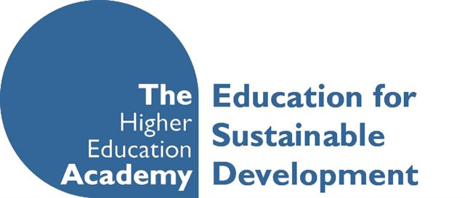





Please return by email to Seek Pang, spang@glos.ac.uk

